# A mini project report on

# CITY GUIDE

*For the award of the degree*

*of*

**BACHELOR OF TECHNOLOGY**

**In**

**COMPUTER SCIENCE AND ENGINEERING**

(II Year - II Semester)

**ADVANCED JAVA PROGRAMMING LAB**

***Submitted by***

**Mr.P.SAMPATH RAKESH Mr.P.MRUDUKAR**

(**19B91A05I6**) (19B91A05I4)



**DEPARTMENT OF COMPUTER SCIENCE AND ENGINEERING**

**SRKR ENGINEERING COLLEGE(A)**

ChinnaAmiram,Bhimavaram,West Godavari Dt.,

[2019-2020]

**DEPARTMENT OF COMPUTER SCIENCE AND ENGINEERING**

**S.R.K.R. ENGINEERING COLLEGE**

**BHIMAVARAM**



*CERTIFICATE*

This is to certify that this is a bonafide work on “**CITY GUIDE**” and has been submitted by Mr.P.SAMPATH RAKESH (19B91A05I6), Mr.P.MRUDUKAR(19B91A05I4), in partial fulfillment of the requirements for the award of the degree of Bachelor of Technology in Computer Science and Engineering, during the academic year 2020-2021. The candidate worked right under my Supervision and guidance.

**Lecturers In-Charge LabCoordinator**

**Sri R.SHIVA SHANKER Sri Ch.SWAROOP**

Assistant Professor, Assistant Professor,

Department of CSE, Department of CSE,

S.R.K.R.Engg.College, S.R.K.R.Engg.College,

Bhimavaram. Bhimavaram.

**ABSTRACT**

If you want to showcase your city and cast its uniqueness in place to visit, jobs to find, things to enjoy, local transportation services for a traveler and other things then it is necessary to give it a web based platform. .City Guide is a web-based software developed in Java programming language to store the details of a city.

The main purpose of this project to help the tourists and other visitors to the city by providing information about hotels,transportation facilities, coaching centres etc.

This Java Project serves the visitors as a guide of the city

For easy and user-friendly access there are 3 specific modulesjobseekers,students,tourist modules in extra to routine services .

In addition to this ,there is seperate module for mayor i.e.,admin to view/delete users and add new services which makes easy for updation.

1. **MODULES**
2. **1 LOGIN MODULE**

In this module any member who have an account registered can login.Nevertheless there is separate login for mayor(admin).

1. 2 **REGISTRATION MODULE**

Here with satisfying the requirements.The user data will be updated in the new users can register easily by filling out all the fields database ifAll fields must be filled. All the requirements are matched.

1. **3 STUDENTS MODULE**

This is module is specifically for students User can view schools ,intermediate colleges,universities,ug colleges and can Navigate to their official sites by just clicking on them.User can also view their choice of coaching centres for their specific course which Suits them.

* 1. **JOBSEEKERS MODULE**

This module is specifically for youngsters coming into the city for new livelihood.It provides different fields in which there are job openings.The user can select the field and view the details of the job.So they can find the job easily in a conivientway.It also shows where there are homes for rent with contact of the owner.

* 1. **TOURIST MODULE**

This module is specifically for tourists visiting the city.They can view the tourist spots and where they are situated in and boom….appear in those spots.It also provides the user to book hotels for their stay .

1.6 **MAYOR MODULE**

This module is only for the admin.No user can access this module other than admin.In this ,admin can view users ,delete any user ,add new transportation services,Add/update/delete job openings ,add/update/delete homes for rent.

1.7 **OTHER MODULES**

Apart from this modules there are few other like view details of hospitals in the city With just choosing which disease related ATMs locations and the name of which bank Bus services operating from the city,Train services operating from the city.

1. **SOFTWARE REQUIREMENT SPECIFICATIONS**

2.1 **PURPOSE**

In this project We can easily get the details of all the city. Anyone with a mobile phone can access the details of the city with complete description. Anyone new to this city can easily understand the features of the city while using this website. Youngsters can get the details of the job openings there in the city. It gives the complete description of the city and all services available in the city.

2.2 **SCOPE**

The scope of this project is to make the citizens easily access Services available in the city. They can get the different cluster of services in the most convenient manner.

2.3 **OBJECTIVE**

City Guide is essential whenever we are visiting a particular city. It gives us valuable information about the city and saves time. The main aim objective of this project is services provided to the users who have registered in the site. The services regarding city political, historical, conventional places, bus routes, home rents profile and jobs details.

2.4 **EXISTING SYSTEM**

In the existing city guide project, User had to visit different sites for different services. User had to search for individual websites for each booking or services available in the city. It may be time consuming and difficult to Browse. In Existing system the person who are visiting a particular city need to gather information from the person who is staying in the city or take the help of the guide in the city.

DRAWBACKS

* Time consuming.
* Had to visit different sites for each purpose.
* It’s a limited system and not user friendly.

2.5 **PROPOSED SYSTEM**

The Proposed System provides an online information about the particular city going to visit. It also provides additional services to the registered user. The development of this new system contains the following activities, which try to automate the entire process keeping in the view of database integration approach.

**ADVANTAGES**

* User Friendliness is provided in the application with various controls provided by system Rich User Interface
* All the city services at one place.
* The city information files can be stored in centralized database which can be maintained by the system.
* The system makes the overall project management much easier and flexible.

2.6 **REQUIREMENT ANALYSIS**

Analysis focuses on producing a model of the system called the analysis model, which is correct, complete, consistent and verifiable. Analysis model is composed mainly of three individual models.

Functional model

Analysis object model

Analysis dynamic model

The functional model represents the use of case diagrams, the object model with class diagram and the dynamic model with state chart and sequence diagrams.

2.7 **FUNCTIONALREQUIREMENTS**

* Complete Search/site map of the entire city for easy access.
* Complete overview of the Businesses in the city.
* Complete history of the city-social, political.
* Secure registration of all users including a personal profile-only at the time of a transaction providence.
* Complete overview of hospitals in the city.
* Complete overview of all commercial services available in the city.

2.8 **NON-FUNCTIONAL REQUIREMENTS**

2.8.1 **RELIABLITY**

This system is more reliable and effective because of the quality of service to the user .

2.8.2 **COST**

The cost of product development and maintenance is minimum.

2.8.3 **PERFORMANCE**

This system is developed in the high-level languages front end using java back end using mysql. It will give response to the end with in the least time.

2.8.4 **SUPPORTABILITY**

Java Data Base Connection supports the system.

2.8.5 **SECURITY**

This system provides high secured data. Only admin can view, alter the user data. This avoids the non-authorized users access the system.

2.9 **PSEUDO REQUIREMENTS**

2.9.1. **SOFTWRAE REQUIREMENTS**

* Operating System - Supports WINDOWS, UNIX/LINUX
* Database – mysql
* J2EE, XML

2.9.2 **HARDWARE REQUIREMENTS**

* Processor - Intel® Core™ i3-6006U CPU @2.00GHz 1.99GHz
* RAM - 2GB or above
* Hard Disk - 250GB or above

**3.DATABASE CONNECTIVITY**

**Table 3. 1 ATMS**

|  |  |
| --- | --- |
| FIELD | TYPE |
| Name | varchar(30) |
| Address | varchar(30) |

**Table 3.2 buses**

|  |  |
| --- | --- |
| FIELD | TYPE |
| Destination | varchar(30) |
| Time | varchar(30) |

Table 3.3 coaching centres

|  |  |
| --- | --- |
| FIELD | TYPE |
| Name | varchar(30) |
| Main | Varchar(30) |
| Field | Varchar(30) |
| Contact no | Varchar(30) |

Table 3.4 houses for rent

|  |  |
| --- | --- |
| FIELD | TYPE |
| Owner name | Varchar(30) |
| Type | Varchar(30) |
| Area | Varchar(30) |
| Rent | int |
| Contact no | Varchar(30) |

Table 3.5 hospitals

|  |  |
| --- | --- |
| FIELD | TYPE |
| Specialization | Varchar(30) |
| Name of hospital | Varchar(30) |
| Contact no | Varchar(30) |
| Address | Varchar(30) |

Table 3.6 jobs

|  |  |
| --- | --- |
| FIELD | TYPE |
| Field | Varchar(30) |
| Role | Varchar(30) |
| Description | Varchar(30) |
| Salary | Int |
| Address | Varchar(30) |
| Company name | Varchar(30) |
| Contact no | Varchar(30) |

Table 3.7 railways

|  |  |
| --- | --- |
| FIELD | TYPE |
| Destination | Varchar(30) |
| Type | Varchar(30) |
| Name | Varchar(30) |

Table 3.8 logins

|  |  |
| --- | --- |
| FIELD | TYPE |
| Name | Varchar(30) |
| Gender | Varchar(30) |
| Role | Varchar(30) |
| Password | Varchar(30) |
| Gender | Varchar(30) |
| Email | Varchar(30) |
| Contact no | Varchar(30) |

1. **OUTPUT SCREENS**

**Fig 4.1 login page**

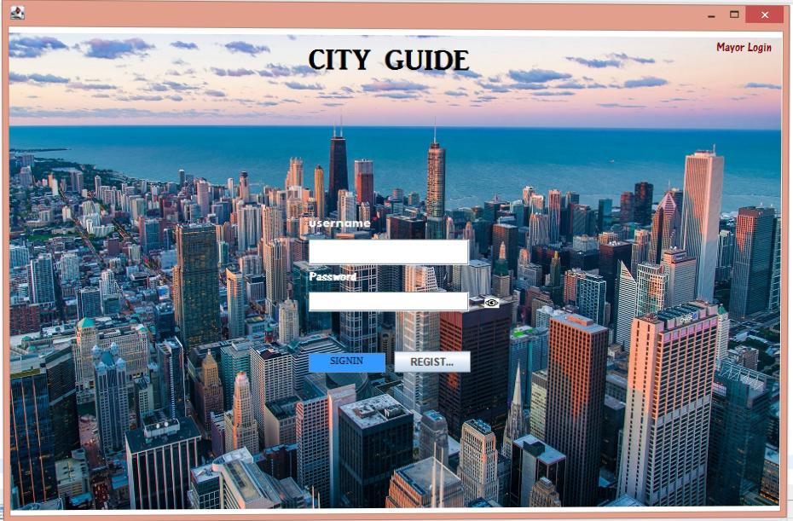

**Fig 4. 2 Registration page**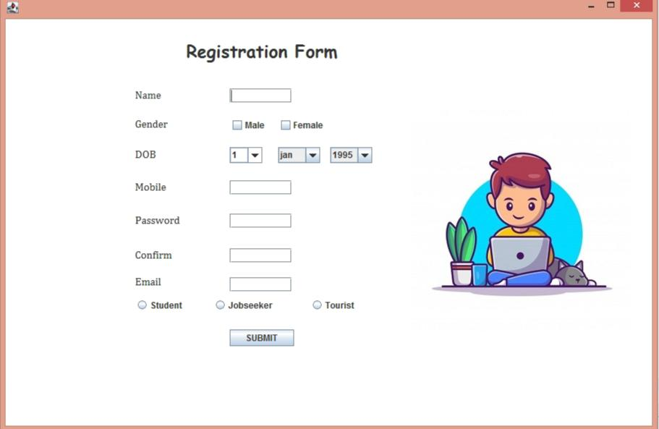

**Fig 4.3 home page** 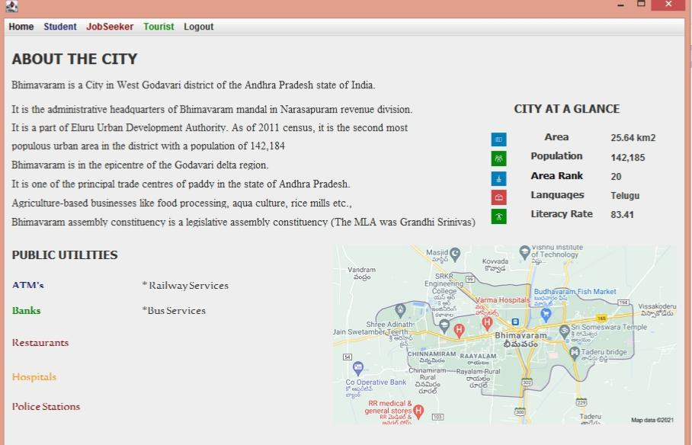

**Fig 4.4 schools universities colleges**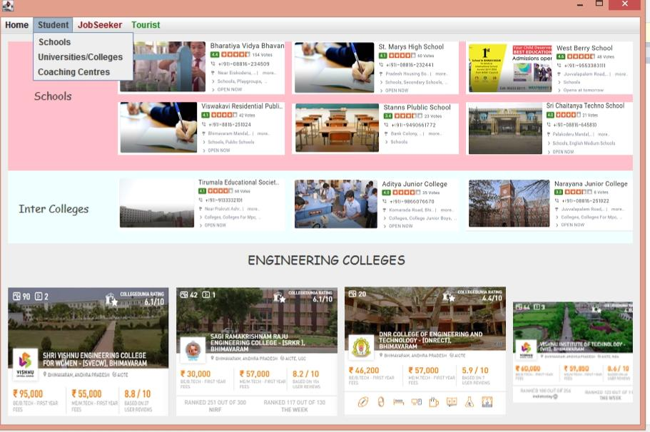

**Fig 4.5 hotels**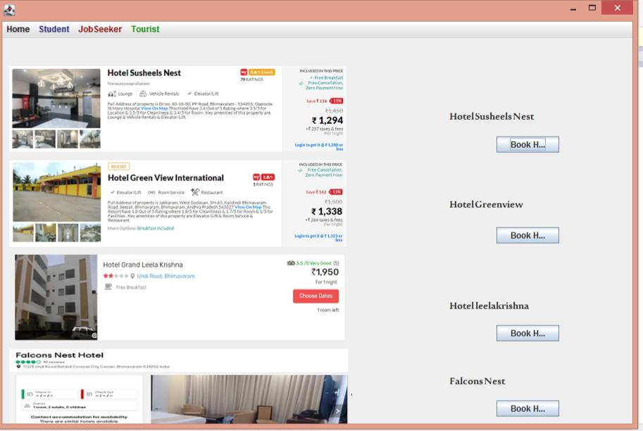

**Fig 4.6 houses for rent**

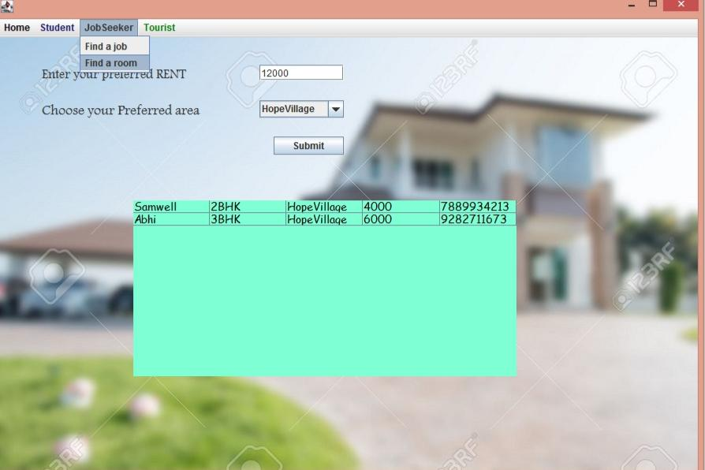

**Fig 4.7 find a job (portal)**

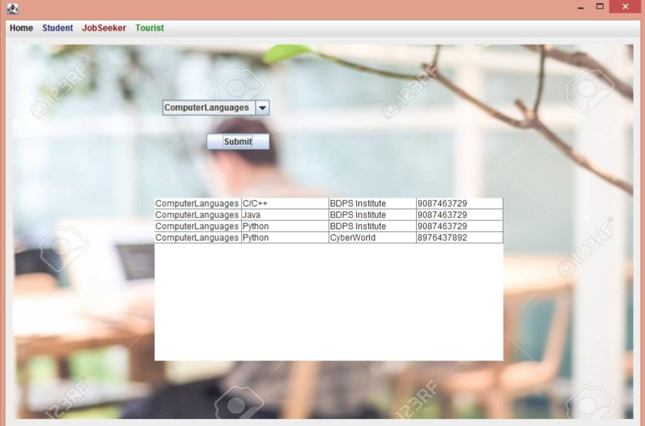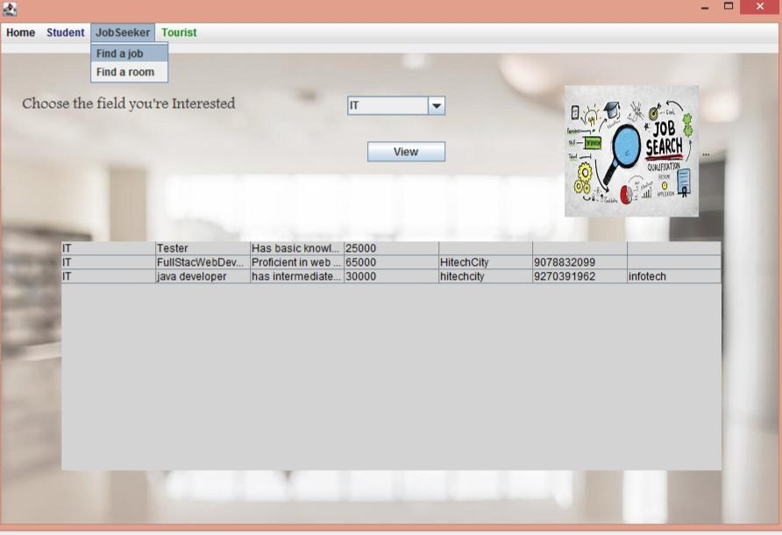

**Fig 4.8 railway services**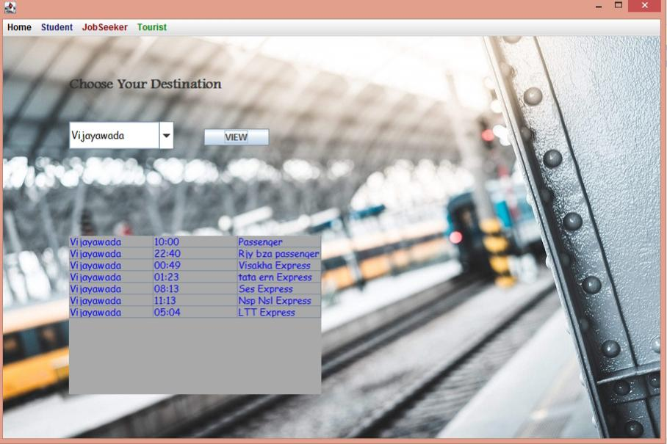

**Fig 4.9 Bus services**

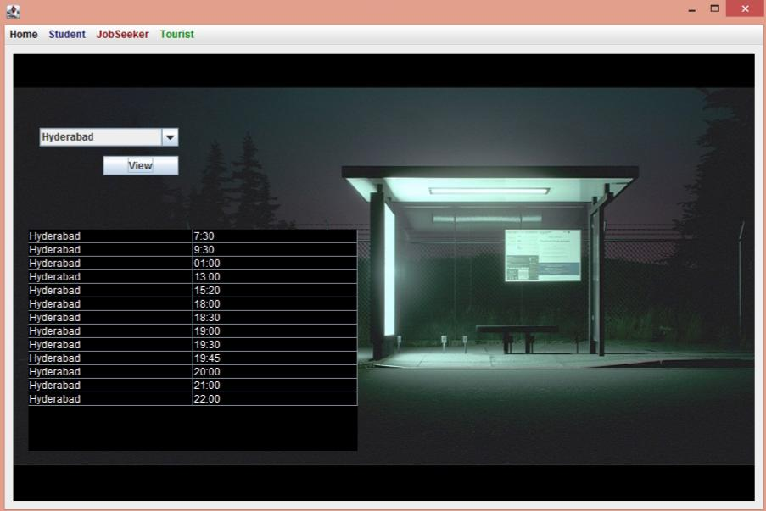

**Fig 4.9 atms**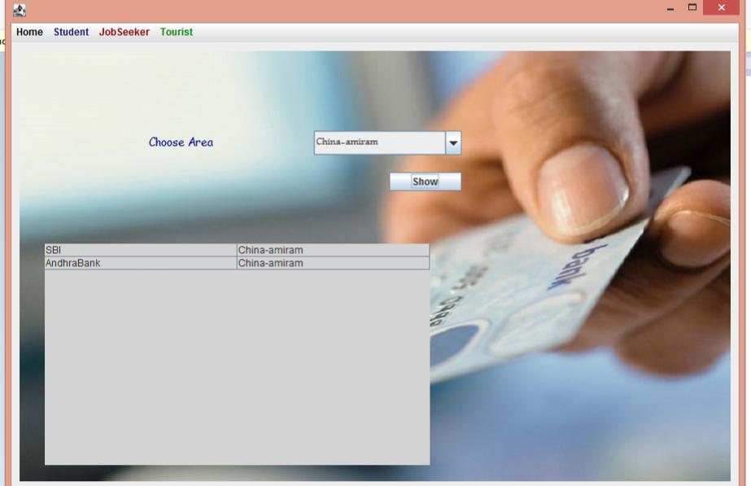

**Fig 4.10 police stations**

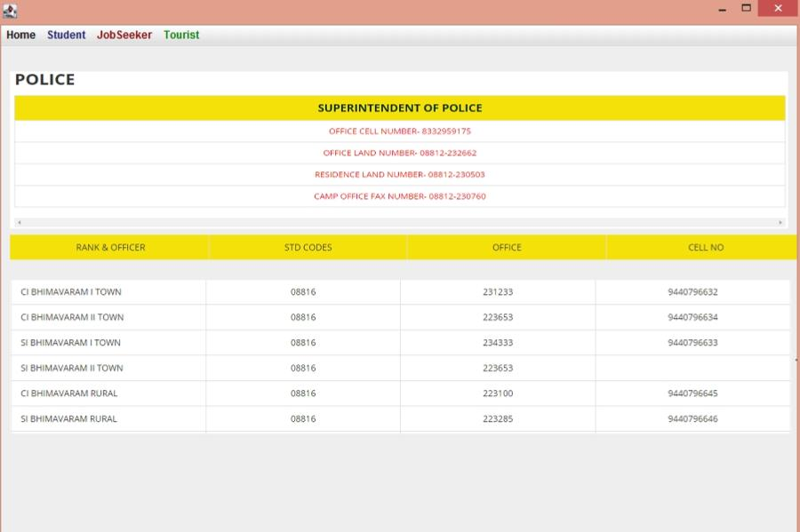

**Fig 4.11 hospital services** 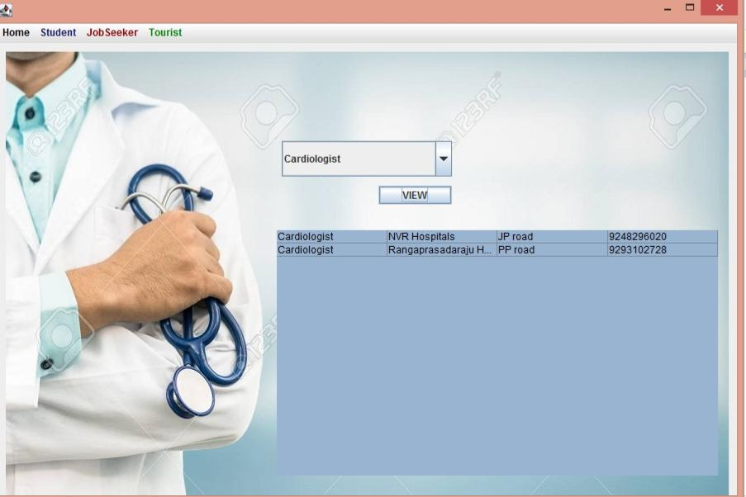

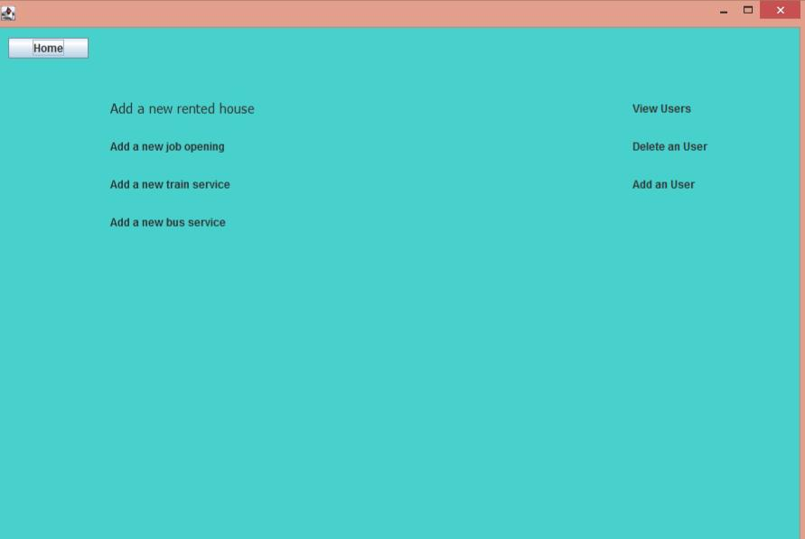

**Fig 4.12 admin home page**

**Fig 4.12.1 add a house for rent**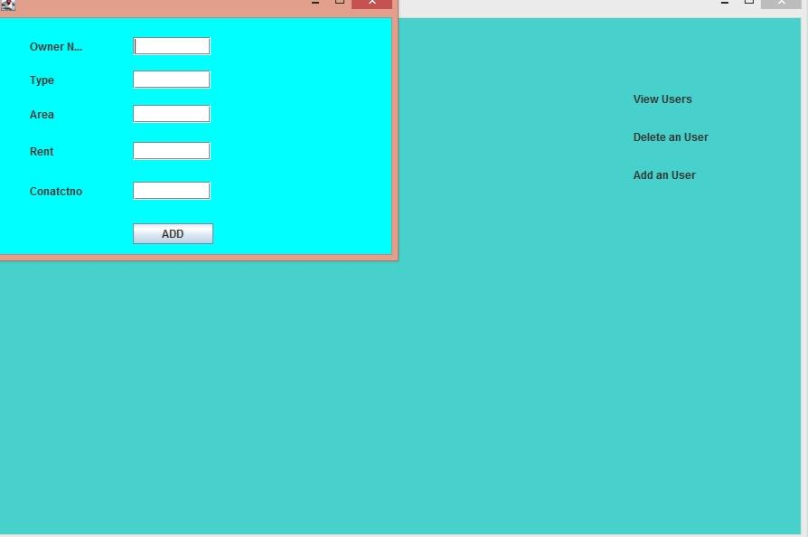

**Fig 4.12.2 add a job**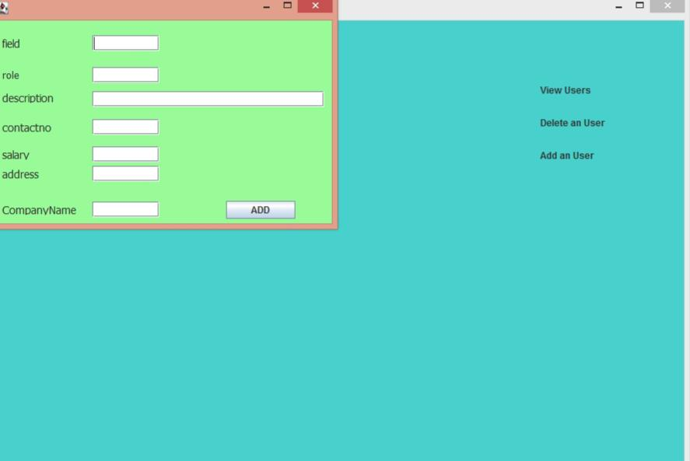

**Fig 4.12.4 add a bus service**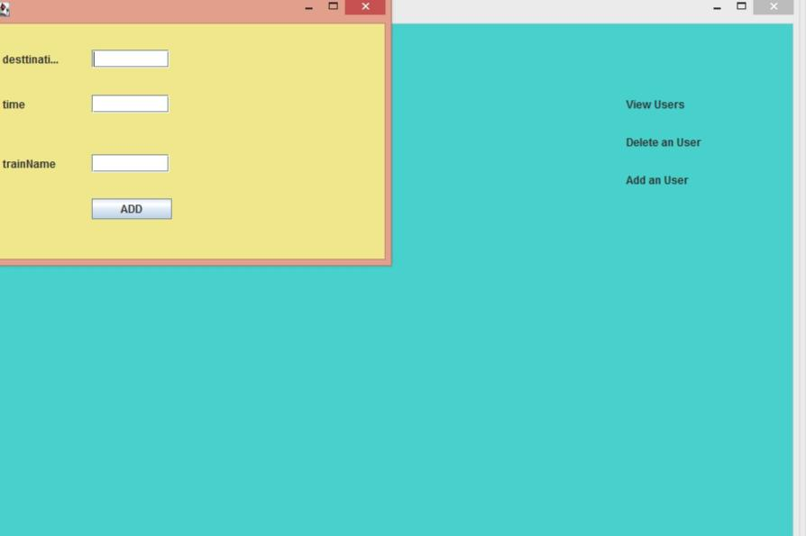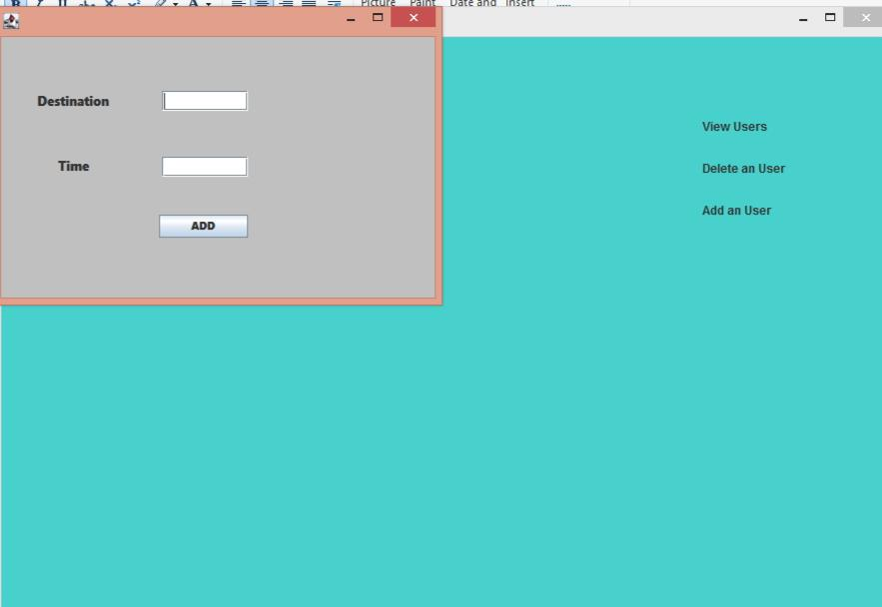

**Fig 4.13 view users**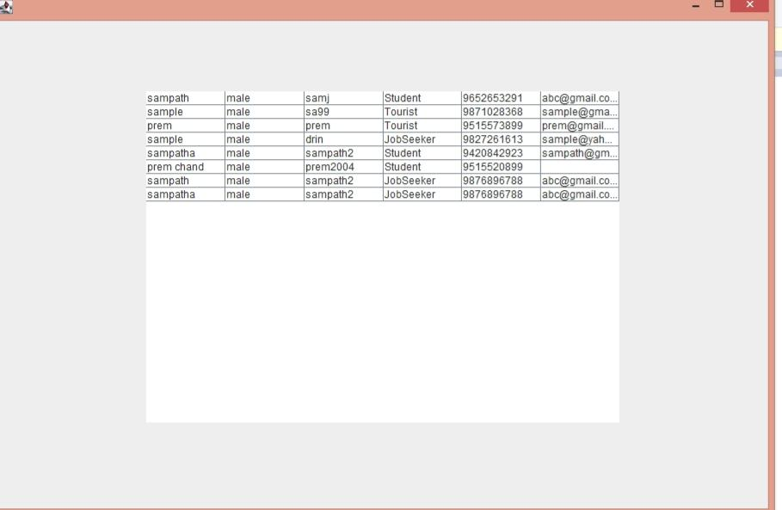

**Fig 4.14 delete an user**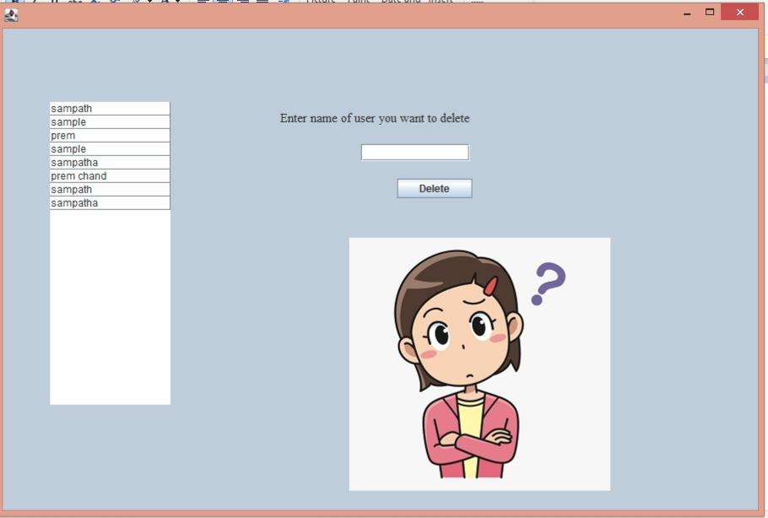

**CODE**

**loginframe.java**

package cityguide;

import java.awt.*;

import javax.swing.*;

import java.sql.*;

public class myframe extends JFrame {

private JPanel contentPane;

private JTextField textField;

private JPasswordField passwordField;

/**

* Launch the application.

*/

public static void main(String[] args) {

EventQueue.invokeLater(new Runnable() {

public void run() {

try {

myframe frame = new myframe();

frame.setVisible(true);

} catch (Exception e) {

e.printStackTrace();

}

}

});

}

/**

* Create the frame.

*/

public myframe() {

setForeground(Color.WHITE);

setBackground(Color.WHITE);

setDefaultCloseOperation(JFrame.EXIT_ON_CLOSE);

setBounds(100, 100, 910, 601);

contentPane = new JPanel();

contentPane.setBackground(Color.WHITE);

contentPane.setForeground(Color.WHITE);

contentPane.setBorder(new EmptyBorder(5, 5, 5, 5));

setContentPane(contentPane);

contentPane.setLayout(null);

textField = new JTextField();

textField.setBackground(SystemColor.textHighlightText);

textField.setFont(new Font("Segoe Print", Font.PLAIN, 13));

textField.setBounds(342, 243, 186, 30);

contentPane.add(textField);

textField.setColumns(10);

JButton btnNewButton = new JButton("SIGNIN");

btnNewButton.setFont(new Font("Sitka Text", Font.PLAIN, 11));

btnNewButton.setBackground(new Color(51, 153, 255));

btnNewButton.setForeground(SystemColor.inactiveCaptionText);

btnNewButton.setBounds(342, 375, 89, 23);

contentPane.add(btnNewButton);

btnNewButton.addActionListener(new ActionListener() {

public void actionPerformed(ActionEvent ef)

{

try

{

String n=textField.getText();

String p=passwordField.getText();

Class.forName("com.mysql.cj.jdbc.Driver");

Connection con=DriverManager.getConnection("jdbc:mysql://localhost:3306/samdb","root","samj");

String ur="select name,password from logins where name='"+n+"' and password='"+p+"'";

Statement st=con.createStatement();

ResultSet rs=st.executeQuery(ur);

if(rs.next())

{

homepage sll=new homepage();

sll.setVisible(true);

}

else

{

JOptionPane.showMessageDialog(null, "Please check your password");

}

}

catch(Exception abc)

{

abc.printStackTrace();

}

}});

JLabel lblNewLabel = new JLabel("username");

lblNewLabel.setForeground(SystemColor.text);

lblNewLabel.setBackground(SystemColor.text);

lblNewLabel.setFont(new Font("Aharoni", Font.BOLD, 15));

lblNewLabel.setBounds(342, 218, 85, 14);

contentPane.add(lblNewLabel);

passwordField = new JPasswordField();

passwordField.setFont(new Font("Segoe Print", Font.PLAIN, 15));

passwordField.setEchoChar('*');

passwordField.setBounds(342, 304, 186, 23);

contentPane.add(passwordField);

JLabel lblNewLabel_3 = new JLabel("Password");

lblNewLabel_3.setForeground(SystemColor.text);

lblNewLabel_3.setFont(new Font("AR CENA", Font.BOLD, 15));

lblNewLabel_3.setBounds(342, 279, 157, 14);

contentPane.add(lblNewLabel_3);

JButton btnNewButton_1 = new JButton("REGISTER");

btnNewButton_1.setBounds(441, 373, 89, 25);

contentPane.add(btnNewButton_1);

JLabel lblNewLabel_1 = new JLabel("Mayor Login");

lblNewLabel_1.addMouseListener(new MouseAdapter() {

@Override

public void mouseClicked(MouseEvent e) {

mayorlogin ml=new mayorlogin();

ml.setVisible(true);

}

});

lblNewLabel_1.setFont(new Font("AR CENA", Font.PLAIN, 15));

lblNewLabel_1.setForeground(new Color(128, 0, 0));

lblNewLabel_1.setBounds(816, 11, 77, 14);

contentPane.add(lblNewLabel_1);

JLabel lblNewLabel_2 = new JLabel("CITY GUIDE");

lblNewLabel_2.setForeground(new Color(0, 0, 0));

lblNewLabel_2.setFont(new Font("AR JULIAN", Font.PLAIN, 34));

lblNewLabel_2.setBounds(342, 11, 221, 48);

contentPane.add(lblNewLabel_2);

JLabel lblNewLabel_7 = new JLabel("show");

lblNewLabel_7.addMouseListener(new MouseAdapter() {

@Override

public void mouseClicked(MouseEvent e) {

passwordField.setEchoChar((char)0);

}

});

lblNewLabel_7.setIcon(new ImageIcon("F:\\chrome downloads\\eye-icon-vector-design-web-260nw-1714712071.jpg"));

lblNewLabel_7.setBounds(546, 310, 17, 14);

contentPane.add(lblNewLabel_7);

JLabel lblNewLabel_5 = new JLabel("New label");

lblNewLabel_5.setIcon(new ImageIcon("F:\\chrome downloads\\city.png"));

lblNewLabel_5.setBounds(0, 0, 893, 562);

contentPane.add(lblNewLabel_5);

btnNewButton_1.addActionListener(new ActionListener() {

public void actionPerformed(ActionEvent e)

{

Regform r=new Regform();

r.setVisible(true);

}

});

}

}

**homepage.java**

package cityguide;

import java.awt.*;

import javax.swing.*;

public class homepage extends JFrame {

/**

* @wbp.nonvisual location=292,-31

*/

private final JTextArea textArea = new JTextArea();

/**

* Launch the application.

*/

public static void main(String[] args) {

EventQueue.invokeLater(new Runnable() {

public void run() {

try {

homepage frame = new homepage();

frame.setVisible(true);

} catch (Exception e) {

e.printStackTrace();

}

}

});

}

/**

* Create the frame.

*/

public homepage() {

setDefaultCloseOperation(JFrame.EXIT_ON_CLOSE);

setBounds(100, 100, 910, 601);

JMenuBar menuBar = new JMenuBar();

setJMenuBar(menuBar);

JMenu mnNewMenu = new JMenu("Home");

mnNewMenu.setForeground(new Color(0, 0, 0));

menuBar.add(mnNewMenu);

JMenu mnNewMenu_1 = new JMenu("Student");

mnNewMenu_1.setForeground(new Color(25, 25, 112));

menuBar.add(mnNewMenu_1);

JMenuItem mntmNewMenuItem_1 = new JMenuItem("Schools");

mntmNewMenuItem_1.addActionListener(new ActionListener() {

public void actionPerformed(ActionEvent e) {

scuframe ss=new scuframe();

ss.setVisible(true);

}

});

mnNewMenu_1.add(mntmNewMenuItem_1);

JMenuItem mntmNewMenuItem_2 = new JMenuItem("Universities/Colleges");

mntmNewMenuItem_2.addActionListener(new ActionListener() {

public void actionPerformed(ActionEvent e) {

scuframe ss=new scuframe();

ss.setVisible(true);

}

});

mnNewMenu_1.add(mntmNewMenuItem_2);

JMenuItem mntmNewMenuItem = new JMenuItem("Coaching Centres");

mntmNewMenuItem.addActionListener(new ActionListener() {

public void actionPerformed(ActionEvent e) {

cc csiu=new cc();

csiu.setVisible(true);

}

});

mnNewMenu_1.add(mntmNewMenuItem);

JMenu mnNewMenu_1_1 = new JMenu("JobSeeker");

mnNewMenu_1_1.setForeground(new Color(139, 0, 0));

menuBar.add(mnNewMenu_1_1);

JMenuItem mntmNewMenuItem_3 = new JMenuItem("Find a job");

mntmNewMenuItem_3.addActionListener(new ActionListener() {

public void actionPerformed(ActionEvent e) {

Jobframe jf=new Jobframe();

jf.setVisible(true);

}

});

mnNewMenu_1_1.add(mntmNewMenuItem_3);

JMenuItem mntmNewMenuItem_4 = new JMenuItem("Find a room");

mnNewMenu_1_1.add(mntmNewMenuItem_4);

JMenu mnNewMenu_1_2 = new JMenu("Tourist");

mnNewMenu_1_2.setForeground(new Color(0, 128, 0));

menuBar.add(mnNewMenu_1_2);

JMenuItem mntmNewMenuItem_5 = new JMenuItem("View Tourist Spots");

mntmNewMenuItem_5.addActionListener(new ActionListener() {

public void actionPerformed(ActionEvent e) {

touristspot tf=new touristspot();

tf.setVisible(true);

}

});

mnNewMenu_1_2.add(mntmNewMenuItem_5);

JMenuItem mntmNewMenuItem_6 = new JMenuItem("View Hotels");

mntmNewMenuItem_6.addActionListener(new ActionListener() {

public void actionPerformed(ActionEvent e) {

hotelframe hf=new hotelframe();

hf.setVisible(true);

}

});

mnNewMenu_1_2.add(mntmNewMenuItem_6);

JMenu mnNewMenu_2 = new JMenu("Logout");

menuBar.add(mnNewMenu_2);

JMenuItem mntmNewMenuItem_7 = new JMenuItem("Logout");

mntmNewMenuItem_7.addActionListener(new ActionListener() {

public void actionPerformed(ActionEvent e) {

myframe mf=new myframe();

mf.setVisible(true);

}

});

mnNewMenu_2.add(mntmNewMenuItem_7);

getContentPane().setLayout(null);

JLabel lblNewLabel = new JLabel("CITY AT A GLANCE");

lblNewLabel.setFont(new Font("Tahoma", Font.BOLD, 15));

lblNewLabel.setBounds(670, 77, 146, 37);

getContentPane().add(lblNewLabel);

JLabel lblNewLabel_1 = new JLabel("25.64 km2");

lblNewLabel_1.setBounds(797, 126, 61, 14);

getContentPane().add(lblNewLabel_1);

JLabel lblNewLabel_2 = new JLabel("Area \r\n");

lblNewLabel_2.setFont(new Font("Tahoma", Font.BOLD, 13));

lblNewLabel_2.setBounds(710, 125, 46, 14);

getContentPane().add(lblNewLabel_2);

JLabel lblNewLabel_2_1 = new JLabel("Population");

lblNewLabel_2_1.setFont(new Font("Tahoma", Font.BOLD, 13));

lblNewLabel_2_1.setBounds(692, 150, 75, 14);

getContentPane().add(lblNewLabel_2_1);

JLabel lblNewLabel_3 = new JLabel("142,185");

lblNewLabel_3.setBounds(797, 152, 46, 14);

getContentPane().add(lblNewLabel_3);

JLabel lblNewLabel_4 = new JLabel("Area Rank");

lblNewLabel_4.setFont(new Font("Tahoma", Font.BOLD, 13));

lblNewLabel_4.setForeground(new Color(0, 0, 0));

lblNewLabel_4.setBounds(692, 176, 75, 14);

getContentPane().add(lblNewLabel_4);

JLabel lblNewLabel_5 = new JLabel("20");

lblNewLabel_5.setBounds(797, 177, 46, 14);

getContentPane().add(lblNewLabel_5);

JLabel lblNewLabel_6 = new JLabel("Languages");

lblNewLabel_6.setFont(new Font("Tahoma", Font.BOLD, 13));

lblNewLabel_6.setBounds(692, 201, 75, 14);

getContentPane().add(lblNewLabel_6);

JLabel lblNewLabel_7 = new JLabel("Telugu");

lblNewLabel_7.setBounds(797, 202, 46, 14);

getContentPane().add(lblNewLabel_7);

JLabel lblNewLabel_8 = new JLabel("Literacy Rate");

lblNewLabel_8.setFont(new Font("Tahoma", Font.BOLD, 12));

lblNewLabel_8.setBounds(692, 226, 91, 14);

getContentPane().add(lblNewLabel_8);

JLabel lblNewLabel_9 = new JLabel("83.41");

lblNewLabel_9.setBounds(797, 227, 46, 14);

getContentPane().add(lblNewLabel_9);

JLabel lblNewLabel_10 = new JLabel("ABOUT THE CITY");

lblNewLabel_10.setFont(new Font("Tahoma", Font.BOLD, 19));

lblNewLabel_10.setBounds(10, 11, 190, 37);

getContentPane().add(lblNewLabel_10);

JLabel lblNewLabel_21 = new JLabel("Banks");

lblNewLabel_21.setForeground(new Color(0, 128, 0));

lblNewLabel_21.setFont(new Font("Urdu Typesetting", Font.BOLD, 15));

lblNewLabel_21.setBounds(10, 346, 46, 22);

getContentPane().add(lblNewLabel_21);

JLabel lblNewLabel_22 = new JLabel("Restaurants");

lblNewLabel_22.setFont(new Font("Urdu Typesetting", Font.PLAIN, 15));

lblNewLabel_22.setForeground(new Color(128, 0, 0));

lblNewLabel_22.setBounds(10, 388, 81, 22);

getContentPane().add(lblNewLabel_22);

JLabel lblNewLabel_23 = new JLabel("Hospitals");

lblNewLabel_23.addMouseListener(new MouseAdapter() {

@Override

public void mouseClicked(MouseEvent e) {

hospitalframe hf=new hospitalframe();

hf.setVisible(true);

}

});

lblNewLabel_23.setFont(new Font("Urdu Typesetting", Font.PLAIN, 15));

lblNewLabel_23.setForeground(new Color(255, 140, 0));

lblNewLabel_23.setBounds(10, 433, 81, 22);

getContentPane().add(lblNewLabel_23);

JLabel lblNewLabel_24 = new JLabel("Police Stations");

lblNewLabel_24.addMouseListener(new MouseAdapter() {

@Override

public void mouseClicked(MouseEvent e) {

policeframe pf=new policeframe();

pf.setVisible(true);

}

});

lblNewLabel_24.setFont(new Font("Urdu Typesetting", Font.PLAIN, 15));

lblNewLabel_24.setForeground(new Color(139, 0, 0));

lblNewLabel_24.setBounds(10, 472, 103, 22);

getContentPane().add(lblNewLabel_24);

JLabel lblNewLabel_28 = new JLabel("* Railway Services");

lblNewLabel_28.addMouseListener(new MouseAdapter() {

@Override

public void mouseClicked(MouseEvent e) {

railframe rf=new railframe();

rf.setVisible(true);

}

});

lblNewLabel_28.setFont(new Font("Urdu Typesetting", Font.PLAIN, 15));

lblNewLabel_28.setBounds(181, 313, 129, 22);

getContentPane().add(lblNewLabel_28);

JLabel lblNewLabel_29 = new JLabel("*Bus Services");

lblNewLabel_29.addMouseListener(new MouseAdapter() {

@Override

public void mouseClicked(MouseEvent e) {

busframe bf=new busframe();

bf.setVisible(true);

}

});

lblNewLabel_29.setFont(new Font("Urdu Typesetting", Font.PLAIN, 15));

lblNewLabel_29.setBounds(181, 346, 113, 22);

getContentPane().add(lblNewLabel_29);

JLabel lblNewLabel_30 = new JLabel("New label");

lblNewLabel_30.setIcon(new ImageIcon("F:\\chrome downloads\\bvr,m.png"));

lblNewLabel_30.setBounds(432, 262, 452, 260);

getContentPane().add(lblNewLabel_30);

JLabel lblNewLabel_31 = new JLabel("New label");

lblNewLabel_31.setIcon(new ImageIcon("F:\\chrome downloads\\Screenshot_20210713-104541_Chrome.jpg"));

lblNewLabel_31.setBounds(640, 126, 20, 20);

getContentPane().add(lblNewLabel_31);

JLabel lblNewLabel_31_1 = new JLabel("New label");

lblNewLabel_31_1.setIcon(new ImageIcon("F:\\chrome downloads\\aaa.jpg"));

lblNewLabel_31_1.setBounds(640, 151, 20, 20);

getContentPane().add(lblNewLabel_31_1);

JLabel lblNewLabel_31_2 = new JLabel("New label");

lblNewLabel_31_2.setIcon(new ImageIcon("F:\\chrome downloads\\20210713_104834.jpg"));

lblNewLabel_31_2.setBounds(640, 177, 20, 20);

getContentPane().add(lblNewLabel_31_2);

JLabel lblNewLabel_31_3 = new JLabel("New label");

lblNewLabel_31_3.setIcon(new ImageIcon("F:\\chrome downloads\\20210713_104700.jpg"));

lblNewLabel_31_3.setBounds(640, 202, 20, 20);

getContentPane().add(lblNewLabel_31_3);

JLabel lblNewLabel_31_4 = new JLabel("New label");

lblNewLabel_31_4.setIcon(new ImageIcon("F:\\chrome downloads\\Screenshot_20210713-104547_Chrome.jpg"));

lblNewLabel_31_4.setBounds(640, 227, 20, 20);

getContentPane().add(lblNewLabel_31_4);

}

}

**regform.java**

package swingreg;

import java.sql.*;

import java.awt.*;

import javax.swing.*;

import java.awt.event.*;

public class Regform extends JFrame {

private JPanel contentPane;

private JTextField textField;

private JPasswordField passwordField;

private JPasswordField passwordField_1;

private JTextField textField_1;

private JTextField textField_2;

/**

* Launch the application.

*/

public static void main(String[] args) {

EventQueue.invokeLater(new Runnable() {

public void run() {

try {

Regform frame = new Regform();

frame.setVisible(true);

} catch (Exception e) {

e.printStackTrace();

}

}

});

}

/**

* Create the frame.

*/

public Regform() {

setDefaultCloseOperation(JFrame.EXIT_ON_CLOSE);

setBounds(100, 100, 910, 601);

contentPane = new JPanel();

contentPane.setBackground(Color.WHITE);

contentPane.setBorder(new EmptyBorder(5, 5, 5, 5));

setContentPane(contentPane);

contentPane.setLayout(null);

JLabel lblNewLabel = new JLabel("Name");

lblNewLabel.setFont(new Font("Cambria", Font.PLAIN, 14));

lblNewLabel.setBounds(179, 98, 77, 14);

contentPane.add(lblNewLabel);

JLabel lblNewLabel_1 = new JLabel("Gender");

lblNewLabel_1.setFont(new Font("Cambria", Font.PLAIN, 15));

lblNewLabel_1.setBounds(179, 137, 46, 14);

contentPane.add(lblNewLabel_1);

JLabel lblNewLabel_2 = new JLabel("DOB");

lblNewLabel_2.setFont(new Font("Cambria", Font.PLAIN, 15));

lblNewLabel_2.setBounds(179, 179, 46, 14);

contentPane.add(lblNewLabel_2);

JLabel lblNewLabel_3 = new JLabel("Mobile");

lblNewLabel_3.setFont(new Font("Cambria", Font.PLAIN, 15));

lblNewLabel_3.setBounds(179, 224, 46, 14);

contentPane.add(lblNewLabel_3);

JLabel lblNewLabel_4 = new JLabel("Password");

lblNewLabel_4.setFont(new Font("Cambria", Font.PLAIN, 15));

lblNewLabel_4.setBounds(179, 270, 77, 14);

contentPane.add(lblNewLabel_4);

JLabel lblNewLabel_5 = new JLabel("Confirm\r\n");

lblNewLabel_5.setFont(new Font("Cambria", Font.PLAIN, 15));

lblNewLabel_5.setBounds(179, 318, 65, 14);

contentPane.add(lblNewLabel_5);

textField = new JTextField();

textField.setBackground(Color.WHITE);

textField.setBounds(310, 96, 86, 20);

contentPane.add(textField);

textField.setColumns(10);

JCheckBox chckbxNewCheckBox = new JCheckBox("Male");

chckbxNewCheckBox.setBackground(Color.WHITE);

chckbxNewCheckBox.setBounds(310, 135, 65, 23);

contentPane.add(chckbxNewCheckBox);

JCheckBox chckbxNewCheckBox_1 = new JCheckBox("Female");

chckbxNewCheckBox_1.setBackground(Color.WHITE);

chckbxNewCheckBox_1.setBounds(377, 135, 97, 23);

contentPane.add(chckbxNewCheckBox_1);

passwordField = new JPasswordField();

passwordField.setBounds(310, 269, 86, 20);

contentPane.add(passwordField);

passwordField_1 = new JPasswordField();

passwordField_1.setBounds(310, 317, 86, 20);

contentPane.add(passwordField_1);

JComboBox comboBox = new JComboBox();

comboBox.setModel(new DefaultComboBoxModel(new String[] {"jan", "feb", "mar", "apr", "may", "jun", "jul", "aug", "sep", "oct", "nov", "dec"}));

comboBox.setSelectedIndex(0);

comboBox.setBounds(377, 177, 58, 22);

contentPane.add(comboBox);

JComboBox comboBox_1 = new JComboBox();

comboBox_1.setBackground(Color.WHITE);

comboBox_1.setModel(new DefaultComboBoxModel(new String[] {"1", "2", "3", "4", "5", "6", "7", "8", "9", "10", "11", "12", "13", "14", "15", "16", "17", "18", "19", "20", "21", "22", "23", "24", "25", "26", "27", "28", "29", "30", "31"}));

comboBox_1.setBounds(310, 177, 45, 22);

contentPane.add(comboBox_1);

JComboBox comboBox_2 = new JComboBox();

comboBox_2.setModel(new DefaultComboBoxModel(new String[] {"1995", "1996", "1997", "1998", "1999", "2000", "2001", "2002", "2003", "2004", "2005"}));

comboBox_2.setBounds(449, 177, 58, 22);

contentPane.add(comboBox_2);

textField_1 = new JTextField();

textField_1.setBounds(310, 223, 86, 20);

contentPane.add(textField_1);

textField_1.setColumns(10);

JRadioButton rdbtnNewRadioButton = new JRadioButton("Student");

rdbtnNewRadioButton.setBackground(Color.WHITE);

rdbtnNewRadioButton.setMnemonic('*');

rdbtnNewRadioButton.setBounds(179, 384, 109, 23);

contentPane.add(rdbtnNewRadioButton);

JRadioButton rdbtnNewRadioButton_1 = new JRadioButton("Jobseeker");

rdbtnNewRadioButton_1.setBackground(Color.WHITE);

rdbtnNewRadioButton_1.setBounds(287, 384, 109, 23);

contentPane.add(rdbtnNewRadioButton_1);

JRadioButton rdbtnNewRadioButton_2 = new JRadioButton("Tourist");

rdbtnNewRadioButton_2.setBackground(Color.WHITE);

rdbtnNewRadioButton_2.setBounds(421, 384, 109, 23);

contentPane.add(rdbtnNewRadioButton_2);

ButtonGroup bg=new ButtonGroup();

bg.add(rdbtnNewRadioButton); bg.add(rdbtnNewRadioButton_2); bg.add(rdbtnNewRadioButton_1);

textField_2 = new JTextField();

textField_2.setBounds(310, 357, 86, 20);

contentPane.add(textField_2);

textField_2.setColumns(10);

JButton btnNewButton = new JButton("SUBMIT");

btnNewButton.addActionListener(new ActionListener() {

public void actionPerformed(ActionEvent e) {

String n,gen,p,m,r,email;

n=textField.getText();

String cp=passwordField_1.getText();

if(chckbxNewCheckBox.isSelected())

{

gen="male";

}

else

{

gen="female";

}

p=passwordField.getText();

m=textField_1.getText();

email= textField_2.getText();

int counter=passwordField.getPassword().length;

String pswd=passwordField_1.getPassword().toString();

if(rdbtnNewRadioButton.isSelected()) {

r="Student";

}

else if(rdbtnNewRadioButton_1.isSelected()) {

r="JobSeeker";

}

else

{

r="Tourist";

}

if(counter<8)

{

JOptionPane.showMessageDialog(null,"password requirements not matched");

}

else

{

if(!p.equalsIgnoreCase(cp))

{

JOptionPane.showMessageDialog(null, "Confirm password and password not matched");

}

else

{

if (m.length()==10)

{

try {

Class.forName("com.mysql.cj.jdbc.Driver");

Connection cont=DriverManager.getConnection("jdbc:mysql://localhost:3306/samdb","root","samj");

PreparedStatement ps=cont.prepareStatement("insert into logins(name,gender,password,role,mobile,email)values(?,?,?,?,?,?);");

ps.setString(1, n);

ps.setString(2, gen);

ps.setString(3, p);

ps.setString(4, r);

ps.setString(5, m);

ps.setString(6, email);

int x=ps.executeUpdate();

if(x>0)

{

JOptionPane.showMessageDialog(null, "Successfully inserted");

}

else

{

JOptionPane.showMessageDialog(null, "not inserted");

}

}

catch(Exception ekk)

{

ekk.printStackTrace();

}

}

else

{

textField_1.setBackground(Color.red);

}

}

}

}

});

btnNewButton.setBounds(310, 429, 89, 23);

contentPane.add(btnNewButton);

JLabel lblNewLabel_6 = new JLabel("Email");

lblNewLabel_6.setFont(new Font("Cambria", Font.PLAIN, 15));

lblNewLabel_6.setBounds(179, 355, 46, 14);

contentPane.add(lblNewLabel_6);

JLabel lblNewLabel_8 = new JLabel("New label");

lblNewLabel_8.setIcon(new ImageIcon("F:\\chrome downloads\\b.jpg"));

lblNewLabel_8.setBounds(559, 126, 306, 307);

contentPane.add(lblNewLabel_8);

JLabel lblNewLabel_9 = new JLabel("Registration Form");

lblNewLabel_9.setFont(new Font("Comic Sans MS", Font.BOLD, 24));

lblNewLabel_9.setHorizontalAlignment(SwingConstants.CENTER);

lblNewLabel_9.setBounds(179, 25, 351, 36);

contentPane.add(lblNewLabel_9);

}

}

**scu.java (schools,colleges,universities)**

package cityguide;

import java.awt.*;

import javax.swing.*;

import java.awt.event.*;

public class scuframe extends JFrame {

private JPanel contentPane;

/**

* Launch the application.

*/

public static void main(String[] args) {

EventQueue.invokeLater(new Runnable() {

public void run() {

try {

scuframe frame = new scuframe();

frame.setVisible(true);

} catch (Exception e) {

e.printStackTrace();

}

}

});

}

/**

* Create the frame.

*/

public scuframe() {

setDefaultCloseOperation(JFrame.EXIT_ON_CLOSE);

setBounds(100, 100, 912, 610);

contentPane = new JPanel();

contentPane.setBorder(new EmptyBorder(5, 5, 5, 5));

setContentPane(contentPane);

JMenuBar menuBar = new JMenuBar();

setJMenuBar(menuBar);

JMenu mnNewMenu = new JMenu("Home");

mnNewMenu.setForeground(new Color(0, 0, 0));

menuBar.add(mnNewMenu);

JMenuItem mntmNewMenuItem_7 = new JMenuItem("HomePage");

mntmNewMenuItem_7.addActionListener(new ActionListener() {

public void actionPerformed(ActionEvent e) {

homepage hp=new homepage();

hp.setVisible(true);}

});

mnNewMenu.add(mntmNewMenuItem_7);

JMenu mnNewMenu_1 = new JMenu("Student");

mnNewMenu_1.setForeground(new Color(25, 25, 112));

menuBar.add(mnNewMenu_1);

JMenuItem mntmNewMenuItem_1 = new JMenuItem("Schools");

mntmNewMenuItem_1.addActionListener(new ActionListener() {

public void actionPerformed(ActionEvent e) {

scuframe scf=new scuframe();

scf.setVisible(true);

}

});

mnNewMenu_1.add(mntmNewMenuItem_1);

JMenuItem mntmNewMenuItem_2 = new JMenuItem("Universities/Colleges");

mntmNewMenuItem_2.addActionListener(new ActionListener() {

public void actionPerformed(ActionEvent e) {

scuframe scf=new scuframe();

scf.setVisible(true);

}

});

mnNewMenu_1.add(mntmNewMenuItem_2);

JMenuItem mntmNewMenuItem = new JMenuItem("Coaching Centres");

mntmNewMenuItem.addActionListener(new ActionListener() {

public void actionPerformed(ActionEvent e) {

cc sihc=new cc();

sihc.setVisible(true);

}

});

mnNewMenu_1.add(mntmNewMenuItem);

JMenu mnNewMenu_1_1 = new JMenu("JobSeeker");

mnNewMenu_1_1.setForeground(new Color(139, 0, 0));

menuBar.add(mnNewMenu_1_1);

JMenuItem mntmNewMenuItem_3 = new JMenuItem("Find a job");

mntmNewMenuItem_3.addActionListener(new ActionListener() {

public void actionPerformed(ActionEvent e) {

Jobframe jf=new Jobframe();

jf.setVisible(true);

}

});

mnNewMenu_1_1.add(mntmNewMenuItem_3);

JMenuItem mntmNewMenuItem_4 = new JMenuItem("Find a room");

mntmNewMenuItem_4.addActionListener(new ActionListener() {

public void actionPerformed(ActionEvent e) {

rentframe rf=new rentframe();

rf.setVisible(true);

}

});

mnNewMenu_1_1.add(mntmNewMenuItem_4);

JMenu mnNewMenu_1_2 = new JMenu("Tourist");

mnNewMenu_1_2.setForeground(new Color(0, 128, 0));

menuBar.add(mnNewMenu_1_2);

JMenuItem mntmNewMenuItem_5 = new JMenuItem("View Tourist Spots");

mntmNewMenuItem_5.addActionListener(new ActionListener() {

public void actionPerformed(ActionEvent e) {

touristspot ts=new touristspot();

ts.setVisible(true);

}

});

mnNewMenu_1_2.add(mntmNewMenuItem_5);

JMenuItem mntmNewMenuItem_6 = new JMenuItem("View Hotels");

mntmNewMenuItem_6.addActionListener(new ActionListener() {

public void actionPerformed(ActionEvent e) {

hotelframe scf=new hotelframe();

scf.setVisible(true);

}

});

mnNewMenu_1_2.add(mntmNewMenuItem_6);

getContentPane().setLayout(null);

contentPane.setLayout(null);

JLabel lblNewLabel = new JLabel("New label");

lblNewLabel.setIcon(new ImageIcon("C:\\Users\\rakesh\\Pictures\\Screenshots\\bvbschool.png"));

lblNewLabel.setBounds(164, 11, 234, 74);

contentPane.add(lblNewLabel);

JLabel lblNewLabel_2 = new JLabel("New label");

lblNewLabel_2.setIcon(new ImageIcon("C:\\Users\\rakesh\\Pictures\\Screenshots\\bsms.png"));

lblNewLabel_2.setBounds(408, 11, 234, 74);

contentPane.add(lblNewLabel_2);

JLabel lblNewLabel_1 = new JLabel("New label");

lblNewLabel_1.setIcon(new ImageIcon("C:\\Users\\rakesh\\Pictures\\Screenshots\\bwb.png"));

lblNewLabel_1.setBounds(652, 11, 234, 74);

contentPane.add(lblNewLabel_1);

JLabel lblNewLabel_3 = new JLabel("New label");

lblNewLabel_3.setIcon(new ImageIcon("C:\\Users\\rakesh\\Pictures\\Screenshots\\Screenshot (54).png"));

lblNewLabel_3.setBounds(164, 96, 234, 74);

contentPane.add(lblNewLabel_3);

JLabel lblNewLabel_4 = new JLabel("New label");

lblNewLabel_4.setIcon(new ImageIcon("C:\\Users\\rakesh\\Pictures\\Screenshots\\bst.png"));

lblNewLabel_4.setBounds(408, 96, 234, 74);

contentPane.add(lblNewLabel_4);

JLabel lblNewLabel_5 = new JLabel("New label");

lblNewLabel_5.setIcon(new ImageIcon("C:\\Users\\rakesh\\Pictures\\Screenshots\\Screenshot (55).png"));

lblNewLabel_5.setBounds(652, 96, 234, 74);

contentPane.add(lblNewLabel_5);

JLabel lblNewLabel_6 = new JLabel("New label");

lblNewLabel_6.setIcon(new ImageIcon("C:\\Users\\rakesh\\Pictures\\Screenshots\\ctir.png"));

lblNewLabel_6.setBounds(164, 203, 234, 74);

contentPane.add(lblNewLabel_6);

JLabel lblNewLabel_7 = new JLabel("New label");

lblNewLabel_7.setIcon(new ImageIcon("C:\\Users\\rakesh\\Pictures\\Screenshots\\Screenshot (56).png"));

lblNewLabel_7.setBounds(408, 203, 234, 74);

contentPane.add(lblNewLabel_7);

JLabel lblNewLabel_8 = new JLabel("New label");

lblNewLabel_8.setIcon(new ImageIcon("C:\\Users\\rakesh\\Pictures\\Screenshots\\Screenshot (57).png"));

lblNewLabel_8.setBounds(652, 203, 234, 74);

contentPane.add(lblNewLabel_8);

JLabel lblNewLabel_9 = new JLabel("New label");

lblNewLabel_9.addMouseListener(new MouseAdapter() {

@Override

public void mouseClicked(MouseEvent e) {

try {

java.awt.Desktop.getDesktop().browse(java.net.URI.create("https://www.google.co.in"));

}

catch(Exception ekk)

{

ekk.printStackTrace();

}

}

});

lblNewLabel_9.setIcon(new ImageIcon("C:\\Users\\rakesh\\Pictures\\Screenshots\\ecv.png"));

lblNewLabel_9.setBounds(10, 355, 226, 183);

contentPane.add(lblNewLabel_9);

JLabel lblNewLabel_9_1 = new JLabel("New label");

lblNewLabel_9_1.setIcon(new ImageIcon("C:\\Users\\rakesh\\Pictures\\Screenshots\\estt.png"));

lblNewLabel_9_1.setBounds(246, 355, 226, 183);

contentPane.add(lblNewLabel_9_1);

JLabel lblNewLabel_9_2 = new JLabel("New label");

lblNewLabel_9_2.setIcon(new ImageIcon("C:\\Users\\rakesh\\Pictures\\Screenshots\\Screenshot (51).png"));

lblNewLabel_9_2.setBounds(482, 355, 226, 183);

contentPane.add(lblNewLabel_9_2);

JLabel lblNewLabel_9_3 = new JLabel("New label");

lblNewLabel_9_3.setIcon(new ImageIcon("C:\\Users\\rakesh\\Pictures\\Screenshots\\Screenshot (50).png"));

lblNewLabel_9_3.setBounds(718, 355, 168, 183);

contentPane.add(lblNewLabel_9_3);

JLabel lblNewLabel_10 = new JLabel("ENGINEERING COLLEGES");

lblNewLabel_10.setFont(new Font("Comic Sans MS", Font.PLAIN, 17));

lblNewLabel_10.setBounds(346, 305, 244, 24);

contentPane.add(lblNewLabel_10);

JLabel lblNewLabel_11 = new JLabel("Inter Colleges");

lblNewLabel_11.setFont(new Font("Comic Sans MS", Font.PLAIN, 15));

lblNewLabel_11.setBounds(25, 233, 111, 24);

contentPane.add(lblNewLabel_11);

JLabel lblNewLabel_12 = new JLabel("Schools");

lblNewLabel_12.setFont(new Font("Comic Sans MS", Font.PLAIN, 15));

lblNewLabel_12.setBounds(46, 80, 75, 14);

contentPane.add(lblNewLabel_12);

JPanel panel = new JPanel();

panel.setBackground(new Color(255, 192, 203));

panel.setBounds(10, 11, 876, 181);

contentPane.add(panel);

JPanel panel_1 = new JPanel();

panel_1.setBackground(new Color(240, 255, 255));

panel_1.setBounds(10, 192, 876, 102);

contentPane.add(panel_1);

}

}

**coachingcentres.java**

package swingreg;

import java.awt.BorderLayout;

import java.awt.Color;

import java.awt.EventQueue;

import java.awt.event.ActionEvent;

import java.awt.event.ActionListener;

import java.sql.Connection;

import java.sql.DriverManager;

import java.sql.ResultSet;

import java.sql.Statement;

import javax.swing.JFrame;

import javax.swing.JMenu;

import javax.swing.JMenuBar;

import javax.swing.JMenuItem;

import javax.swing.JPanel;

import javax.swing.border.EmptyBorder;

import net.proteanit.sql.DbUtils;

import javax.swing.JComboBox;

import javax.swing.DefaultComboBoxModel;

import javax.swing.JButton;

import javax.swing.JTable;

import javax.swing.JLabel;

import javax.swing.ImageIcon;

public class cc extends JFrame {

private JPanel contentPane;

private JTable table;

/**

* Launch the application.

*/

public static void main(String[] args) {

EventQueue.invokeLater(new Runnable() {

public void run() {

try {

cc frame = new cc();

frame.setVisible(true);

} catch (Exception e) {

e.printStackTrace();

}

}

});

}

/**

* Create the frame.

*/

public cc() {

setDefaultCloseOperation(JFrame.EXIT_ON_CLOSE);

setBounds(100, 100, 910, 610);

contentPane = new JPanel();

contentPane.setBorder(new EmptyBorder(5, 5, 5, 5));

setContentPane(contentPane);

JMenuBar menuBar = new JMenuBar();

setJMenuBar(menuBar);

JMenu mnNewMenu = new JMenu("Home");

mnNewMenu.setForeground(new Color(0, 0, 0));

menuBar.add(mnNewMenu);

JMenuItem mntmNewMenuItem_7 = new JMenuItem("HomePage");

mntmNewMenuItem_7.addActionListener(new ActionListener() {

public void actionPerformed(ActionEvent e) {

homepage hp=new homepage();

hp.setVisible(true);

}

});

mnNewMenu.add(mntmNewMenuItem_7);

JMenu mnNewMenu_1 = new JMenu("Student");

mnNewMenu_1.setForeground(new Color(25, 25, 112));

menuBar.add(mnNewMenu_1);

JMenuItem mntmNewMenuItem_1 = new JMenuItem("Schools");

mntmNewMenuItem_1.addActionListener(new ActionListener() {

public void actionPerformed(ActionEvent e) {

scuframe scf=new scuframe();

scf.setVisible(true);

}

});

mnNewMenu_1.add(mntmNewMenuItem_1);

JMenuItem mntmNewMenuItem_2 = new JMenuItem("Universities/Colleges");

mntmNewMenuItem_2.addActionListener(new ActionListener() {

public void actionPerformed(ActionEvent e) {

scuframe scf=new scuframe();

scf.setVisible(true);

}

});

mnNewMenu_1.add(mntmNewMenuItem_2);

JMenuItem mntmNewMenuItem = new JMenuItem("Coaching Centres");

mntmNewMenuItem.addActionListener(new ActionListener() {

public void actionPerformed(ActionEvent e) {

cc sihc=new cc();

sihc.setVisible(true);

}

});

mnNewMenu_1.add(mntmNewMenuItem);

JMenu mnNewMenu_1_1 = new JMenu("JobSeeker");

mnNewMenu_1_1.setForeground(new Color(139, 0, 0));

menuBar.add(mnNewMenu_1_1);

JMenuItem mntmNewMenuItem_3 = new JMenuItem("Find a job");

mntmNewMenuItem_3.addActionListener(new ActionListener() {

public void actionPerformed(ActionEvent e) {

Jobframe jf=new Jobframe();

jf.setVisible(true);

}

});

mnNewMenu_1_1.add(mntmNewMenuItem_3);

JMenuItem mntmNewMenuItem_4 = new JMenuItem("Find a room");

mntmNewMenuItem_4.addActionListener(new ActionListener() {

public void actionPerformed(ActionEvent e) {

rentframe rf=new rentframe();

rf.setVisible(true);

}

});

mnNewMenu_1_1.add(mntmNewMenuItem_4);

JMenu mnNewMenu_1_2 = new JMenu("Tourist");

mnNewMenu_1_2.setForeground(new Color(0, 128, 0));

menuBar.add(mnNewMenu_1_2);

JMenuItem mntmNewMenuItem_5 = new JMenuItem("View Tourist Spots");

mntmNewMenuItem_5.addActionListener(new ActionListener() {

public void actionPerformed(ActionEvent e) {

touristspot ts=new touristspot();

ts.setVisible(true);

}

});

mnNewMenu_1_2.add(mntmNewMenuItem_5);

JMenuItem mntmNewMenuItem_6 = new JMenuItem("View Hotels");

mntmNewMenuItem_6.addActionListener(new ActionListener() {

public void actionPerformed(ActionEvent e) {

hotelframe scf=new hotelframe();

scf.setVisible(true);

}

});

mnNewMenu_1_2.add(mntmNewMenuItem_6);

getContentPane().setLayout(null);

contentPane.setLayout(null);

JComboBox comboBox = new JComboBox();

comboBox.setModel(new DefaultComboBoxModel(new String[] {"ComputerLanguages", "Photoshoppe", "Mechanics", "Trending Tech", "Comp Exams"}));

comboBox.setBounds(221, 89, 151, 22);

contentPane.add(comboBox);

JButton btnNewButton = new JButton("Submit");

btnNewButton.addActionListener(new ActionListener() {

public void actionPerformed(ActionEvent e) {

String data=comboBox.getSelectedItem().toString();

try {

Class.forName("com.mysql.cj.jdbc.Driver");

Connection cont=DriverManager.getConnection("jdbc:mysql://localhost:3306/samdb","root","samj");

String ur="select * from coaching where field='"+data+"'";

Statement st=cont.createStatement();

ResultSet rs=st.executeQuery(ur);

table.setModel(DbUtils.resultSetToTableModel(rs));

}

catch(Exception ex)

{

ex.printStackTrace();

}

}

});

btnNewButton.setBounds(283, 136, 89, 23);

contentPane.add(btnNewButton);

table = new JTable();

table.setBounds(210, 227, 491, 229);

contentPane.add(table);

JLabel lblNewLabel = new JLabel("New label");

lblNewLabel.setIcon(new ImageIcon("F:\\chrome downloads\\85892612-blurred-background-blur-man-using-lap-top-computer-at-office-in-casual-style.jpg"));

lblNewLabel.setBounds(10, 11, 874, 527);

contentPane.add(lblNewLabel);

}

}

**jobsframe.java**

package cityguide;

import java.awt.*;

import javax.swing.*;

import java.sql.*;

public class Jobframe extends JFrame {

private JPanel contentPane;

private JTable table;

private JLabel lblNewLabel;

private JLabel lblNewLabel_1;

/**

* Launch the application.

*/

public static void main(String[] args) {

EventQueue.invokeLater(new Runnable() {

public void run() {

try {

Jobframe frame = new Jobframe();

frame.setVisible(true);

} catch (Exception e) {

e.printStackTrace();

}

}

});

}

/**

* Create the frame.

*/

public Jobframe() {

setDefaultCloseOperation(JFrame.EXIT_ON_CLOSE);

setBounds(100, 100, 903, 610);

contentPane = new JPanel();

contentPane.setBorder(new EmptyBorder(5, 5, 5, 5));

setContentPane(contentPane);

contentPane.setLayout(null);

JMenuBar menuBar = new JMenuBar();

setJMenuBar(menuBar);

JMenu mnNewMenu = new JMenu("Home");

mnNewMenu.setForeground(new Color(0, 0, 0));

menuBar.add(mnNewMenu);

JMenuItem mntmNewMenuItem_7 = new JMenuItem("HomePage");

mntmNewMenuItem_7.addActionListener(new ActionListener() {

public void actionPerformed(ActionEvent e) {

homepage hp=new homepage();

hp.setVisible(true);

}

});

mnNewMenu.add(mntmNewMenuItem_7);

JMenu mnNewMenu_1 = new JMenu("Student");

mnNewMenu_1.setForeground(new Color(25, 25, 112));

menuBar.add(mnNewMenu_1);

JMenuItem mntmNewMenuItem_1 = new JMenuItem("Schools");

mntmNewMenuItem_1.addActionListener(new ActionListener() {

public void actionPerformed(ActionEvent e) {

scuframe scf=new scuframe();

scf.setVisible(true);

}

});

mnNewMenu_1.add(mntmNewMenuItem_1);

JMenuItem mntmNewMenuItem_2 = new JMenuItem("Universities/Colleges");

mntmNewMenuItem_2.addActionListener(new ActionListener() {

public void actionPerformed(ActionEvent e) {

scuframe scf=new scuframe();

scf.setVisible(true);

}

});

mnNewMenu_1.add(mntmNewMenuItem_2);

JMenuItem mntmNewMenuItem = new JMenuItem("Coaching Centres");

mntmNewMenuItem.addActionListener(new ActionListener() {

public void actionPerformed(ActionEvent e) {

cc sihc=new cc();

sihc.setVisible(true);

}

});

mnNewMenu_1.add(mntmNewMenuItem);

JMenu mnNewMenu_1_1 = new JMenu("JobSeeker");

mnNewMenu_1_1.setForeground(new Color(139, 0, 0));

menuBar.add(mnNewMenu_1_1);

JMenuItem mntmNewMenuItem_3 = new JMenuItem("Find a job");

mntmNewMenuItem_3.addActionListener(new ActionListener() {

public void actionPerformed(ActionEvent e) {

Jobframe jf=new Jobframe();

jf.setVisible(true);

}

});

mnNewMenu_1_1.add(mntmNewMenuItem_3);

JMenuItem mntmNewMenuItem_4 = new JMenuItem("Find a room");

mntmNewMenuItem_4.addActionListener(new ActionListener() {

public void actionPerformed(ActionEvent e) {

rentframe rf=new rentframe();

rf.setVisible(true);

}

});

mnNewMenu_1_1.add(mntmNewMenuItem_4);

JMenu mnNewMenu_1_2 = new JMenu("Tourist");

mnNewMenu_1_2.setForeground(new Color(0, 128, 0));

menuBar.add(mnNewMenu_1_2);

JMenuItem mntmNewMenuItem_5 = new JMenuItem("View Tourist Spots");

mntmNewMenuItem_5.addActionListener(new ActionListener() {

public void actionPerformed(ActionEvent e) {

touristspot ts=new touristspot();

ts.setVisible(true);

}

});

mnNewMenu_1_2.add(mntmNewMenuItem_5);

JMenuItem mntmNewMenuItem_6 = new JMenuItem("View Hotels");

mntmNewMenuItem_6.addActionListener(new ActionListener() {

public void actionPerformed(ActionEvent e) {

hotelframe scf=new hotelframe();

scf.setVisible(true);

}

});

mnNewMenu_1_2.add(mntmNewMenuItem_6);

getContentPane().setLayout(null);

JComboBox comboBox = new JComboBox();

comboBox.setModel(new DefaultComboBoxModel(new String[] {"IT", "Hardware", "Art"}));

comboBox.setBounds(395, 60, 112, 22);

contentPane.add(comboBox);

JButton btnNewButton = new JButton("View\r\n");

btnNewButton.addActionListener(new ActionListener() {

public void actionPerformed(ActionEvent e) {

String data=comboBox.getSelectedItem().toString();

try {

Class.forName("com.mysql.cj.jdbc.Driver");

Connection cont=DriverManager.getConnection("jdbc:mysql://localhost:3306/samdb","root","samj");

String ur="select * from jobs where field='"+data+"'";

Statement st=cont.createStatement();

ResultSet rs=st.executeQuery(ur);

table.setModel(DbUtils.resultSetToTableModel(rs));

}

catch(Exception ex)

{

ex.printStackTrace();

}

}

});

btnNewButton.setBounds(418, 112, 89, 23);

contentPane.add(btnNewButton);

table = new JTable();

table.setForeground(new Color(0, 0, 0));

table.setBackground(new Color(211, 211, 211));

table.setBounds(69, 226, 753, 261);

contentPane.add(table);

lblNewLabel = new JLabel("Choose the field you're Interested");

lblNewLabel.setFont(new Font("Andalus", Font.PLAIN, 18));

lblNewLabel.setBounds(24, 53, 319, 33);

contentPane.add(lblNewLabel);

lblNewLabel_1 = new JLabel("New label");

lblNewLabel_1.setIcon(new ImageIcon("F:\\chrome downloads\\jobbb.jpg"));

lblNewLabel_1.setBounds(643, 38, 165, 170);

contentPane.add(lblNewLabel_1);

JLabel lblNewLabel_2 = new JLabel("New label");

lblNewLabel_2.setIcon(new ImageIcon("F:\\chrome downloads\\zoom-chinnapong.jpg"));

lblNewLabel_2.setBounds(0, 11, 887, 538);

contentPane.add(lblNewLabel_2);

}

}

**rentframe.java**

package cityguide;

import java.awt.*;

import javax.swing.*;

import java.sql.*;

public class rentframe extends JFrame {

private JPanel contentPane;

private JTextField textField;

private JTable table;

/**

* Launch the application.

*/

public static void main(String[] args) {

EventQueue.invokeLater(new Runnable() {

public void run() {

try {

rentframe frame = new rentframe();

frame.setVisible(true);

} catch (Exception e) {

e.printStackTrace();

}

}

});

}

/**

* Create the frame.

*/

public rentframe() {

setDefaultCloseOperation(JFrame.EXIT_ON_CLOSE);

setBounds(100, 100, 902, 611);

contentPane = new JPanel();

contentPane.setBorder(new EmptyBorder(5, 5, 5, 5));

setContentPane(contentPane);

contentPane.setLayout(null);

JMenuBar menuBar = new JMenuBar();

setJMenuBar(menuBar);

JMenu mnNewMenu = new JMenu("Home");

mnNewMenu.setForeground(new Color(0, 0, 0));

menuBar.add(mnNewMenu);

JMenuItem mntmNewMenuItem_7 = new JMenuItem("HomePage");

mntmNewMenuItem_7.addActionListener(new ActionListener() {

public void actionPerformed(ActionEvent e) {

homepage hp=new homepage();

hp.setVisible(true);

}

});

mnNewMenu.add(mntmNewMenuItem_7);

JMenu mnNewMenu_1 = new JMenu("Student");

mnNewMenu_1.setForeground(new Color(25, 25, 112));

menuBar.add(mnNewMenu_1);

JMenuItem mntmNewMenuItem_1 = new JMenuItem("Schools");

mntmNewMenuItem_1.addActionListener(new ActionListener() {

public void actionPerformed(ActionEvent e) {

scuframe scf=new scuframe();

scf.setVisible(true);

}

});

mnNewMenu_1.add(mntmNewMenuItem_1);

JMenuItem mntmNewMenuItem_2 = new JMenuItem("Universities/Colleges");

mntmNewMenuItem_2.addActionListener(new ActionListener() {

public void actionPerformed(ActionEvent e) {

scuframe scf=new scuframe();

scf.setVisible(true);

}

});

mnNewMenu_1.add(mntmNewMenuItem_2);

JMenuItem mntmNewMenuItem = new JMenuItem("Coaching Centres");

mntmNewMenuItem.addActionListener(new ActionListener() {

public void actionPerformed(ActionEvent e) {

cc sihc=new cc();

sihc.setVisible(true);

}

});

mnNewMenu_1.add(mntmNewMenuItem);

JMenu mnNewMenu_1_1 = new JMenu("JobSeeker");

mnNewMenu_1_1.setForeground(new Color(139, 0, 0));

menuBar.add(mnNewMenu_1_1);

JMenuItem mntmNewMenuItem_3 = new JMenuItem("Find a job");

mntmNewMenuItem_3.addActionListener(new ActionListener() {

public void actionPerformed(ActionEvent e) {

Jobframe jf=new Jobframe();

jf.setVisible(true);

}

});

mnNewMenu_1_1.add(mntmNewMenuItem_3);

JMenuItem mntmNewMenuItem_4 = new JMenuItem("Find a room");

mntmNewMenuItem_4.addActionListener(new ActionListener() {

public void actionPerformed(ActionEvent e) {

rentframe rf=new rentframe();

rf.setVisible(true);

}

});

mnNewMenu_1_1.add(mntmNewMenuItem_4);

JMenu mnNewMenu_1_2 = new JMenu("Tourist");

mnNewMenu_1_2.setForeground(new Color(0, 128, 0));

menuBar.add(mnNewMenu_1_2);

JMenuItem mntmNewMenuItem_5 = new JMenuItem("View Tourist Spots");

mntmNewMenuItem_5.addActionListener(new ActionListener() {

public void actionPerformed(ActionEvent e) {

touristspot ts=new touristspot();

ts.setVisible(true);

}

});

mnNewMenu_1_2.add(mntmNewMenuItem_5);

JMenuItem mntmNewMenuItem_6 = new JMenuItem("View Hotels");

mntmNewMenuItem_6.addActionListener(new ActionListener() {

public void actionPerformed(ActionEvent e) {

hotelframe scf=new hotelframe();

scf.setVisible(true);

}

});

mnNewMenu_1_2.add(mntmNewMenuItem_6);

getContentPane().setLayout(null);

JLabel lblNewLabel = new JLabel("Enter your preferred RENT");

lblNewLabel.setFont(new Font("Andalus", Font.PLAIN, 17));

lblNewLabel.setBounds(54, 25, 433, 44);

contentPane.add(lblNewLabel);

textField = new JTextField();

textField.setBounds(330, 35, 107, 20);

contentPane.add(textField);

textField.setColumns(10);

table = new JTable();

table.setFont(new Font("Comic Sans MS", Font.PLAIN, 14));

table.setForeground(new Color(0, 0, 0));

table.setBackground(new Color(127, 255, 212));

table.setBounds(170, 207, 486, 223);

contentPane.add(table);

JComboBox comboBox = new JComboBox();

comboBox.setModel(new DefaultComboBoxModel(new String[] {"", "GreenWoods", "HitechCity", "HopeVillage", "UnionCetre"}));

comboBox.setBounds(330, 80, 107, 22);

contentPane.add(comboBox);

JButton btnNewButton_1 = new JButton("Submit");

btnNewButton_1.addActionListener(new ActionListener() {

public void actionPerformed(ActionEvent e) {

String ar=textField.getText();

int i=Integer.parseInt(ar);

String data=comboBox.getSelectedItem().toString();

try {

Class.forName("com.mysql.cj.jdbc.Driver");

Connection cont=DriverManager.getConnection("jdbc:mysql://localhost:3306/samdb","root","samj");

String ur="select * from forrent where AREA='"+data+"' and RENT<'"+i+"'";

Statement st=cont.createStatement();

ResultSet rs=st.executeQuery(ur);

table.setModel(DbUtils.resultSetToTableModel(rs));

}

catch(Exception ex)

{

ex.printStackTrace();

}

}

});

btnNewButton_1.setBounds(348, 126, 89, 23);

contentPane.add(btnNewButton_1);

JLabel lblChooseYourPreferred = new JLabel("Choose your Preferred area");

lblChooseYourPreferred.setFont(new Font("Andalus", Font.PLAIN, 18));

lblChooseYourPreferred.setBounds(54, 71, 433, 44);

contentPane.add(lblChooseYourPreferred);

JLabel lblNewLabel_1 = new JLabel("New label");

lblNewLabel_1.setIcon(new ImageIcon("F:\\chrome downloads\\53315141-blur-house-background.jpg"));

lblNewLabel_1.setBounds(0, 0, 886, 550);

contentPane.add(lblNewLabel_1);

}

}

**touristframe.java**

package cityguide;

import java.awt.*;

import javax.swing.*;

import java.awt.Font;

public class touristspot extends JFrame {

private JPanel contentPane;

/**

* Launch the application.

*/

public static void main(String[] args) {

EventQueue.invokeLater(new Runnable() {

public void run() {

try {

touristspot frame = new touristspot();

frame.setVisible(true);

} catch (Exception e) {

e.printStackTrace();

}

}

});

}

/**

* Create the frame.

*/

public touristspot() {

setDefaultCloseOperation(JFrame.EXIT_ON_CLOSE);

setBounds(100, 100, 911, 609);

contentPane = new JPanel();

contentPane.setBorder(new EmptyBorder(5, 5, 5, 5));

setContentPane(contentPane);

JMenuBar menuBar = new JMenuBar();

setJMenuBar(menuBar);

JMenu mnNewMenu = new JMenu("Home");

mnNewMenu.setForeground(new Color(0, 0, 0));

menuBar.add(mnNewMenu);

JMenuItem mntmNewMenuItem_7 = new JMenuItem("HomePage");

mntmNewMenuItem_7.addActionListener(new ActionListener() {

public void actionPerformed(ActionEvent e) {

homepage hp=new homepage();

hp.setVisible(true);

}

});

mnNewMenu.add(mntmNewMenuItem_7);

JMenu mnNewMenu_1 = new JMenu("Student");

mnNewMenu_1.setForeground(new Color(25, 25, 112));

menuBar.add(mnNewMenu_1);

JMenuItem mntmNewMenuItem_1 = new JMenuItem("Schools");

mntmNewMenuItem_1.addActionListener(new ActionListener() {

public void actionPerformed(ActionEvent e) {

scuframe scf=new scuframe();

scf.setVisible(true);

}

});

mnNewMenu_1.add(mntmNewMenuItem_1);

JMenuItem mntmNewMenuItem_2 = new JMenuItem("Universities/Colleges");

mntmNewMenuItem_2.addActionListener(new ActionListener() {

public void actionPerformed(ActionEvent e) {

scuframe scf=new scuframe();

scf.setVisible(true);

}

});

mnNewMenu_1.add(mntmNewMenuItem_2);

JMenuItem mntmNewMenuItem = new JMenuItem("Coaching Centres");

mntmNewMenuItem.addActionListener(new ActionListener() {

public void actionPerformed(ActionEvent e) {

cc sihc=new cc();

sihc.setVisible(true);

}

});

mnNewMenu_1.add(mntmNewMenuItem);

JMenu mnNewMenu_1_1 = new JMenu("JobSeeker");

mnNewMenu_1_1.setForeground(new Color(139, 0, 0));

menuBar.add(mnNewMenu_1_1);

JMenuItem mntmNewMenuItem_3 = new JMenuItem("Find a job");

mntmNewMenuItem_3.addActionListener(new ActionListener() {

public void actionPerformed(ActionEvent e) {

Jobframe jf=new Jobframe();

jf.setVisible(true);

}

});

mnNewMenu_1_1.add(mntmNewMenuItem_3);

JMenuItem mntmNewMenuItem_4 = new JMenuItem("Find a room");

mntmNewMenuItem_4.addActionListener(new ActionListener() {

public void actionPerformed(ActionEvent e) {

rentframe rf=new rentframe();

rf.setVisible(true);

}

});

mnNewMenu_1_1.add(mntmNewMenuItem_4);

JMenu mnNewMenu_1_2 = new JMenu("Tourist");

mnNewMenu_1_2.setForeground(new Color(0, 128, 0));

menuBar.add(mnNewMenu_1_2);

JMenuItem mntmNewMenuItem_5 = new JMenuItem("View Tourist Spots");

mntmNewMenuItem_5.addActionListener(new ActionListener() {

public void actionPerformed(ActionEvent e) {

touristspot ts=new touristspot();

ts.setVisible(true);

}

});

mnNewMenu_1_2.add(mntmNewMenuItem_5);

JMenuItem mntmNewMenuItem_6 = new JMenuItem("View Hotels");

mntmNewMenuItem_6.addActionListener(new ActionListener() {

public void actionPerformed(ActionEvent e) {

hotelframe scf=new hotelframe();

scf.setVisible(true);

}

});

mnNewMenu_1_2.add(mntmNewMenuItem_6);

contentPane.setLayout(null);

getContentPane().setLayout(null);

JLabel lblNewLabel = new JLabel("New label");

lblNewLabel.setIcon(new ImageIcon("F:\\chrome downloads\\maxresdefault (1).jpg"));

lblNewLabel.setBounds(24, 21, 243, 173);

contentPane.add(lblNewLabel);

JLabel lblNewLabel_1 = new JLabel("New label");

lblNewLabel_1.setIcon(new ImageIcon("F:\\chrome downloads\\37278930_1885837448147655_1820813228649742336_n.jpg"));

lblNewLabel_1.setBounds(451, 21, 320, 173);

contentPane.add(lblNewLabel_1);

JLabel lblNewLabel_2 = new JLabel("New label");

lblNewLabel_2.setIcon(new ImageIcon("F:\\chrome downloads\\download.jpg"));

lblNewLabel_2.setBounds(12, 281, 256, 173);

contentPane.add(lblNewLabel_2);

JLabel lblNewLabel_3 = new JLabel("New label");

lblNewLabel_3.setIcon(new ImageIcon("F:\\chrome downloads\\cache20190625_055236_big73368773-2e01-40ed-a510-787b1aee68cd_big.jpg"));

lblNewLabel_3.setBounds(624, 281, 199, 151);

contentPane.add(lblNewLabel_3);

JLabel lblNewLabel_4 = new JLabel("New label");

lblNewLabel_4.setIcon(new ImageIcon("F:\\chrome downloads\\img-20190810-170436-largejpg.jpg"));

lblNewLabel_4.setBounds(361, 284, 214, 145);

contentPane.add(lblNewLabel_4);

JLabel lblNewLabel_5 = new JLabel("Rupanthara church");

lblNewLabel_5.setForeground(Color.WHITE);

lblNewLabel_5.setFont(new Font("Comic Sans MS", Font.PLAIN, 14));

lblNewLabel_5.setBounds(24, 189, 164, 43);

contentPane.add(lblNewLabel_5);

JLabel lblNewLabel_6 = new JLabel("P.P Road");

lblNewLabel_6.setForeground(Color.WHITE);

lblNewLabel_6.setFont(new Font("Comic Sans MS", Font.PLAIN, 11));

lblNewLabel_6.setBounds(24, 230, 46, 14);

contentPane.add(lblNewLabel_6);

JLabel lblNewLabel_7 = new JLabel("Undi Road");

lblNewLabel_7.setForeground(Color.WHITE);

lblNewLabel_7.setBounds(488, 231, 69, 14);

contentPane.add(lblNewLabel_7);

JLabel lblNewLabel_5_1 = new JLabel("Geetha Multiplex");

lblNewLabel_5_1.setForeground(Color.WHITE);

lblNewLabel_5_1.setFont(new Font("Comic Sans MS", Font.PLAIN, 14));

lblNewLabel_5_1.setBounds(488, 189, 164, 43);

contentPane.add(lblNewLabel_5_1);

JLabel lblNewLabel_8 = new JLabel("Gunupudi");

lblNewLabel_8.setForeground(Color.WHITE);

lblNewLabel_8.setBounds(12, 523, 46, 14);

contentPane.add(lblNewLabel_8);

JLabel lblNewLabel_9 = new JLabel("P.P Road");

lblNewLabel_9.setForeground(Color.WHITE);

lblNewLabel_9.setBounds(361, 523, 46, 14);

contentPane.add(lblNewLabel_9);

JLabel lblNewLabel_5_2 = new JLabel("Someswara Temple\r\n");

lblNewLabel_5_2.setForeground(Color.WHITE);

lblNewLabel_5_2.setFont(new Font("Comic Sans MS", Font.PLAIN, 14));

lblNewLabel_5_2.setBounds(10, 469, 164, 43);

contentPane.add(lblNewLabel_5_2);

JLabel lblNewLabel_5_3 = new JLabel("Mavullama Temple");

lblNewLabel_5_3.setForeground(Color.WHITE);

lblNewLabel_5_3.setFont(new Font("Comic Sans MS", Font.PLAIN, 14));

lblNewLabel_5_3.setBounds(361, 469, 164, 43);

contentPane.add(lblNewLabel_5_3);

JLabel lblNewLabel_5_4 = new JLabel("Veeramma Park");

lblNewLabel_5_4.setForeground(Color.WHITE);

lblNewLabel_5_4.setFont(new Font("Comic Sans MS", Font.PLAIN, 14));

lblNewLabel_5_4.setBounds(607, 469, 164, 43);

contentPane.add(lblNewLabel_5_4);

JLabel lblNewLabel_10 = new JLabel("Near Busstand");

lblNewLabel_10.setForeground(Color.WHITE);

lblNewLabel_10.setBounds(607, 523, 87, 14);

contentPane.add(lblNewLabel_10);

JLabel lblNewLabel_11 = new JLabel("New label");

lblNewLabel_11.setIcon(new ImageIcon("F:\\chrome downloads\\dream.jpg"));

lblNewLabel_11.setBounds(0, 0, 895, 548);

contentPane.add(lblNewLabel_11);

}

}

**Hotels.java**

package cityguide;

import java.awt.*;

import javax.swing.*;

public class hotelframe extends JFrame {

private JPanel contentPane;

/**

* Launch the application.

*/

public static void main(String[] args) {

EventQueue.invokeLater(new Runnable() {

public void run() {

try {

hotelframe frame = new hotelframe();

frame.setVisible(true);

} catch (Exception e) {

e.printStackTrace();

}

}

});

}

/**

* Create the frame.

*/

public hotelframe() {

setDefaultCloseOperation(JFrame.EXIT_ON_CLOSE);

setBounds(100, 100, 911, 610);

contentPane = new JPanel();

contentPane.setBorder(new EmptyBorder(5, 5, 5, 5));

setContentPane(contentPane);

JMenuBar menuBar = new JMenuBar();

setJMenuBar(menuBar);

JMenu mnNewMenu = new JMenu("Home");

mnNewMenu.setForeground(new Color(0, 0, 0));

menuBar.add(mnNewMenu);

JMenuItem mntmNewMenuItem_7 = new JMenuItem("HomePage");

mntmNewMenuItem_7.addActionListener(new ActionListener() {

public void actionPerformed(ActionEvent e) {

homepage hp=new homepage();

hp.setVisible(true);

}

});

mnNewMenu.add(mntmNewMenuItem_7);

JMenu mnNewMenu_1 = new JMenu("Student");

mnNewMenu_1.setForeground(new Color(25, 25, 112));

menuBar.add(mnNewMenu_1);

JMenuItem mntmNewMenuItem_1 = new JMenuItem("Schools");

mntmNewMenuItem_1.addActionListener(new ActionListener() {

public void actionPerformed(ActionEvent e) {

scuframe scf=new scuframe();

scf.setVisible(true);

}

});

mnNewMenu_1.add(mntmNewMenuItem_1);

JMenuItem mntmNewMenuItem_2 = new JMenuItem("Universities/Colleges");

mntmNewMenuItem_2.addActionListener(new ActionListener() {

public void actionPerformed(ActionEvent e) {

scuframe scf=new scuframe();

scf.setVisible(true);

}

});

mnNewMenu_1.add(mntmNewMenuItem_2);

JMenuItem mntmNewMenuItem = new JMenuItem("Coaching Centres");

mntmNewMenuItem.addActionListener(new ActionListener() {

public void actionPerformed(ActionEvent e) {

cc sihc=new cc();

sihc.setVisible(true);

}

});

mnNewMenu_1.add(mntmNewMenuItem);

JMenu mnNewMenu_1_1 = new JMenu("JobSeeker");

mnNewMenu_1_1.setForeground(new Color(139, 0, 0));

menuBar.add(mnNewMenu_1_1);

JMenuItem mntmNewMenuItem_3 = new JMenuItem("Find a job");

mntmNewMenuItem_3.addActionListener(new ActionListener() {

public void actionPerformed(ActionEvent e) {

Jobframe jf=new Jobframe();

jf.setVisible(true);

}

});

mnNewMenu_1_1.add(mntmNewMenuItem_3);

JMenuItem mntmNewMenuItem_4 = new JMenuItem("Find a room");

mntmNewMenuItem_4.addActionListener(new ActionListener() {

public void actionPerformed(ActionEvent e) {

rentframe rf=new rentframe();

rf.setVisible(true);

}

});

mnNewMenu_1_1.add(mntmNewMenuItem_4);

JMenu mnNewMenu_1_2 = new JMenu("Tourist");

mnNewMenu_1_2.setForeground(new Color(0, 128, 0));

menuBar.add(mnNewMenu_1_2);

JMenuItem mntmNewMenuItem_5 = new JMenuItem("View Tourist Spots");

mntmNewMenuItem_5.addActionListener(new ActionListener() {

public void actionPerformed(ActionEvent e) {

touristspot ts=new touristspot();

ts.setVisible(true);

}

});

mnNewMenu_1_2.add(mntmNewMenuItem_5);

JMenuItem mntmNewMenuItem_6 = new JMenuItem("View Hotels");

mntmNewMenuItem_6.addActionListener(new ActionListener() {

public void actionPerformed(ActionEvent e) {

hotelframe scf=new hotelframe();

scf.setVisible(true);

}

});

mnNewMenu_1_2.add(mntmNewMenuItem_6);

getContentPane().setLayout(null);

contentPane.setLayout(null);

JLabel lblNewLabel_1 = new JLabel("New label");

lblNewLabel_1.setIcon(new ImageIcon("C:\\Users\\rakesh\\Pictures\\Screenshots\\Screenshot (45).png"));

lblNewLabel_1.setBounds(10, 40, 479, 123);

contentPane.add(lblNewLabel_1);

JButton btnNewButton = new JButton("Book Here");

btnNewButton.addActionListener(new ActionListener() {

public void actionPerformed(ActionEvent e) {

try {

java.awt.Desktop.getDesktop().browse(java.net.URI.create("https://www.makemytrip.com/hotels/bhimavaram-hotels.html"));

}

catch(Exception ekk)

{

ekk.printStackTrace();

}

}

});

btnNewButton.setBounds(702, 140, 89, 23);

contentPane.add(btnNewButton);

JLabel lblNewLabel_1_1 = new JLabel("New label");

lblNewLabel_1_1.setIcon(new ImageIcon("C:\\Users\\rakesh\\Pictures\\Screenshots\\Screenshot (47).png"));

lblNewLabel_1_1.setBounds(10, 174, 479, 123);

contentPane.add(lblNewLabel_1_1);

JLabel lblNewLabel_1_1_1 = new JLabel("New label");

lblNewLabel_1_1_1.setIcon(new ImageIcon("C:\\Users\\rakesh\\Pictures\\Screenshots\\Screenshot (49).png"));

lblNewLabel_1_1_1.setBounds(10, 308, 479, 123);

contentPane.add(lblNewLabel_1_1_1);

JLabel lblNewLabel_1_1_2 = new JLabel("New label");

lblNewLabel_1_1_2.setIcon(new ImageIcon("C:\\Users\\rakesh\\Pictures\\Screenshots\\Screenshot (48).png"));

lblNewLabel_1_1_2.setBounds(10, 442, 487, 123);

contentPane.add(lblNewLabel_1_1_2);

JButton btnNewButton_1 = new JButton("Book Here");

btnNewButton_1.addActionListener(new ActionListener() {

public void actionPerformed(ActionEvent e) {

try {

java.awt.Desktop.getDesktop().browse(java.net.URI.create("https://www.yatra.com/hotels/hotels-in-bhimavaram/hotel-sri-greeen-view-international"));

}

catch(Exception ekk)

{

ekk.printStackTrace();

}

}

});

btnNewButton_1.setBounds(702, 269, 89, 23);

contentPane.add(btnNewButton_1);

JButton btnNewButton_2 = new JButton("Book Here");

btnNewButton_2.addActionListener(new ActionListener() {

public void actionPerformed(ActionEvent e) {

try {

java.awt.Desktop.getDesktop().browse(java.net.URI.create("https://www.yatra.com/hotels/hotels-in-bhimavaram/hotel-grand-leela-krishna"));

}

catch(Exception ekk)

{

ekk.printStackTrace();

}

}

});

btnNewButton_2.setBounds(702, 408, 89, 23);

contentPane.add(btnNewButton_2);

JButton btnNewButton_3 = new JButton("Book Here");

btnNewButton_3.addActionListener(new ActionListener() {

public void actionPerformed(ActionEvent e) {

try {

java.awt.Desktop.getDesktop().browse(java.net.URI.create("https://www.cleartrip.com/hotels/details/falcons-nest-bhimavaram-710644"));

}

catch(Exception ekk)

{

ekk.printStackTrace();

}

}

});

btnNewButton_3.setBounds(702, 515, 89, 23);

contentPane.add(btnNewButton_3);

JLabel lblNewLabel = new JLabel("Hotel Susheels Nest");

lblNewLabel.setFont(new Font("Urdu Typesetting", Font.BOLD, 15));

lblNewLabel.setBounds(635, 93, 156, 31);

contentPane.add(lblNewLabel);

JLabel lblNewLabel_5 = new JLabel("Hotel Greenview");

lblNewLabel_5.setFont(new Font("Urdu Typesetting", Font.BOLD, 15));

lblNewLabel_5.setBounds(635, 212, 164, 43);

contentPane.add(lblNewLabel_5);

JLabel lblHotelLeelakrishna = new JLabel("Hotel leelakrishna");

lblHotelLeelakrishna.setFont(new Font("Urdu Typesetting", Font.BOLD, 15));

lblHotelLeelakrishna.setBounds(635, 362, 156, 31);

contentPane.add(lblHotelLeelakrishna);

JLabel lblFalconsNest = new JLabel("Falcons Nest");

lblFalconsNest.setFont(new Font("Urdu Typesetting", Font.BOLD, 15));

lblFalconsNest.setBounds(635, 469, 156, 31);

contentPane.add(lblFalconsNest);

}

}

**railframe.java**

package cityguide;

import java.awt.*;

import net.proteanit.sql.*;

import javax.swing.*;

import java.sql.*;

public class railframe extends JFrame {

private JPanel contentPane;

private JTable table;

/**

* Launch the application.

*/

public static void main(String[] args) {

EventQueue.invokeLater(new Runnable() {

public void run() {

try {

railframe frame = new railframe();

frame.setVisible(true);

} catch (Exception e) {

e.printStackTrace();

}

}

});

}

/**

* Create the frame.

*/

public railframe() {

setDefaultCloseOperation(JFrame.EXIT_ON_CLOSE);

setBounds(100, 100, 912, 610);

contentPane = new JPanel();

contentPane.setBackground(Color.WHITE);

contentPane.setBorder(new EmptyBorder(5, 5, 5, 5));

setContentPane(contentPane);

contentPane.setLayout(null);

JMenuBar menuBar = new JMenuBar();

setJMenuBar(menuBar);

JMenu mnNewMenu = new JMenu("Home");

mnNewMenu.setForeground(new Color(0, 0, 0));

menuBar.add(mnNewMenu);

JMenuItem mntmNewMenuItem_7 = new JMenuItem("HomePage");

mntmNewMenuItem_7.addActionListener(new ActionListener() {

public void actionPerformed(ActionEvent e) {

homepage hp=new homepage();

hp.setVisible(true);

}

});

mnNewMenu.add(mntmNewMenuItem_7);

JMenu mnNewMenu_1 = new JMenu("Student");

mnNewMenu_1.setForeground(new Color(25, 25, 112));

menuBar.add(mnNewMenu_1);

JMenuItem mntmNewMenuItem_1 = new JMenuItem("Schools");

mntmNewMenuItem_1.addActionListener(new ActionListener() {

public void actionPerformed(ActionEvent e) {

scuframe scf=new scuframe();

scf.setVisible(true);

}

});

mnNewMenu_1.add(mntmNewMenuItem_1);

JMenuItem mntmNewMenuItem_2 = new JMenuItem("Universities/Colleges");

mntmNewMenuItem_2.addActionListener(new ActionListener() {

public void actionPerformed(ActionEvent e) {

scuframe scf=new scuframe();

scf.setVisible(true);

}

});

mnNewMenu_1.add(mntmNewMenuItem_2);

JMenuItem mntmNewMenuItem = new JMenuItem("Coaching Centres");

mntmNewMenuItem.addActionListener(new ActionListener() {

public void actionPerformed(ActionEvent e) {

cc sihc=new cc();

sihc.setVisible(true);

}

});

mnNewMenu_1.add(mntmNewMenuItem);

JMenu mnNewMenu_1_1 = new JMenu("JobSeeker");

mnNewMenu_1_1.setForeground(new Color(139, 0, 0));

menuBar.add(mnNewMenu_1_1);

JMenuItem mntmNewMenuItem_3 = new JMenuItem("Find a job");

mntmNewMenuItem_3.addActionListener(new ActionListener() {

public void actionPerformed(ActionEvent e) {

Jobframe jf=new Jobframe();

jf.setVisible(true);

}

});

mnNewMenu_1_1.add(mntmNewMenuItem_3);

JMenuItem mntmNewMenuItem_4 = new JMenuItem("Find a room");

mntmNewMenuItem_4.addActionListener(new ActionListener() {

public void actionPerformed(ActionEvent e) {

rentframe rf=new rentframe();

rf.setVisible(true);

}

});

mnNewMenu_1_1.add(mntmNewMenuItem_4);

JMenu mnNewMenu_1_2 = new JMenu("Tourist");

mnNewMenu_1_2.setForeground(new Color(0, 128, 0));

menuBar.add(mnNewMenu_1_2);

JMenuItem mntmNewMenuItem_5 = new JMenuItem("View Tourist Spots");

mntmNewMenuItem_5.addActionListener(new ActionListener() {

public void actionPerformed(ActionEvent e) {

touristspot ts=new touristspot();

ts.setVisible(true);

}

});

mnNewMenu_1_2.add(mntmNewMenuItem_5);

JMenuItem mntmNewMenuItem_6 = new JMenuItem("View Hotels");

mntmNewMenuItem_6.addActionListener(new ActionListener() {

public void actionPerformed(ActionEvent e) {

hotelframe scf=new hotelframe();

scf.setVisible(true);

}

});

mnNewMenu_1_2.add(mntmNewMenuItem_6);

getContentPane().setLayout(null);

JComboBox comboBox = new JComboBox();

comboBox.setBackground(Color.WHITE);

comboBox.setForeground(new Color(0, 0, 0));

comboBox.setFont(new Font("Comic Sans MS", Font.PLAIN, 14));

comboBox.setMaximumRowCount(4);

comboBox.setModel(new DefaultComboBoxModel(new String[] {"Vijayawada", "Secundrebad", "Vizag", "Rajhamundry", "Chennai", "Bengaluru", "Kakinada"}));

comboBox.setSelectedIndex(0);

comboBox.setBounds(90, 116, 143, 38);

contentPane.add(comboBox);

JButton btnNewButton = new JButton("VIEW");

btnNewButton.addActionListener(new ActionListener() {

public void actionPerformed(ActionEvent e) {

btnNewButton.addActionListener(new ActionListener() {

public void actionPerformed(ActionEvent e) {

String data=comboBox.getSelectedItem().toString();

try {

Class.forName("com.mysql.cj.jdbc.Driver");

Connection cont=DriverManager.getConnection("jdbc:mysql://localhost:3306/samdb","root","samj");

String ur="select * from railways where dest='"+data+"'";

Statement st=cont.createStatement();

ResultSet rs=st.executeQuery(ur);

table.setModel(DbUtils.resultSetToTableModel(rs));

}

catch(Exception ex)

{

ex.printStackTrace();

}

}});

}

});

btnNewButton.setBounds(274, 126, 89, 23);

contentPane.add(btnNewButton);

JLabel lblNewLabel_1 = new JLabel("Choose Your Destination");

lblNewLabel_1.setFont(new Font("Andalus", Font.BOLD, 19));

lblNewLabel_1.setBounds(90, 50, 217, 31);

contentPane.add(lblNewLabel_1);

table = new JTable();

table.setBackground(new Color(169, 169, 169));

table.setForeground(new Color(0, 0, 255));

table.setFont(new Font("Comic Sans MS", Font.PLAIN, 13));

table.setBounds(90, 272, 344, 216);

contentPane.add(table);

JLabel lblNewLabel = new JLabel("New label");

lblNewLabel.setIcon(new ImageIcon("F:\\chrome downloads\\old-steel-construction-railway-station-blurred-background-2210x1473.jpg"));

lblNewLabel.setBounds(0, 0, 896, 549);

contentPane.add(lblNewLabel);

}

}

**busframe.java**

package cityguide;

import java.awt.*;

import javax.swing.*;

import net.proteanit.sql.DbUtils;

public class busframe extends JFrame {

private JPanel contentPane;

private JTable table;

/**

* Launch the application.

*/

public static void main(String[] args) {

EventQueue.invokeLater(new Runnable() {

public void run() {

try {

busframe frame = new busframe();

frame.setVisible(true);

} catch (Exception e) {

e.printStackTrace();

}

}

});

}

/**

* Create the frame.

*/

public busframe() {

setDefaultCloseOperation(JFrame.EXIT_ON_CLOSE);

setBounds(100, 100, 910, 610);

contentPane = new JPanel();

contentPane.setBorder(new EmptyBorder(5, 5, 5, 5));

setContentPane(contentPane);

contentPane.setLayout(null);

JMenuBar menuBar = new JMenuBar();

setJMenuBar(menuBar);

JMenu mnNewMenu = new JMenu("Home");

mnNewMenu.setForeground(new Color(0, 0, 0));

menuBar.add(mnNewMenu);

JMenuItem mntmNewMenuItem_7 = new JMenuItem("HomePage");

mntmNewMenuItem_7.addActionListener(new ActionListener() {

public void actionPerformed(ActionEvent e) {

homepage hp=new homepage();

hp.setVisible(true);

}

});

mnNewMenu.add(mntmNewMenuItem_7);

JMenu mnNewMenu_1 = new JMenu("Student");

mnNewMenu_1.setForeground(new Color(25, 25, 112));

menuBar.add(mnNewMenu_1);

JMenuItem mntmNewMenuItem_1 = new JMenuItem("Schools");

mntmNewMenuItem_1.addActionListener(new ActionListener() {

public void actionPerformed(ActionEvent e) {

scuframe scf=new scuframe();

scf.setVisible(true);

}

});

mnNewMenu_1.add(mntmNewMenuItem_1);

JMenuItem mntmNewMenuItem_2 = new JMenuItem("Universities/Colleges");

mntmNewMenuItem_2.addActionListener(new ActionListener() {

public void actionPerformed(ActionEvent e) {

scuframe scf=new scuframe();

scf.setVisible(true);

}

});

mnNewMenu_1.add(mntmNewMenuItem_2);

JMenuItem mntmNewMenuItem = new JMenuItem("Coaching Centres");

mntmNewMenuItem.addActionListener(new ActionListener() {

public void actionPerformed(ActionEvent e) {

cc sihc=new cc();

sihc.setVisible(true);

}

});

mnNewMenu_1.add(mntmNewMenuItem);

JMenu mnNewMenu_1_1 = new JMenu("JobSeeker");

mnNewMenu_1_1.setForeground(new Color(139, 0, 0));

menuBar.add(mnNewMenu_1_1);

JMenuItem mntmNewMenuItem_3 = new JMenuItem("Find a job");

mntmNewMenuItem_3.addActionListener(new ActionListener() {

public void actionPerformed(ActionEvent e) {

Jobframe jf=new Jobframe();

jf.setVisible(true);

}

});

mnNewMenu_1_1.add(mntmNewMenuItem_3);

JMenuItem mntmNewMenuItem_4 = new JMenuItem("Find a room");

mntmNewMenuItem_4.addActionListener(new ActionListener() {

public void actionPerformed(ActionEvent e) {

rentframe rf=new rentframe();

rf.setVisible(true);

}

});

mnNewMenu_1_1.add(mntmNewMenuItem_4);

JMenu mnNewMenu_1_2 = new JMenu("Tourist");

mnNewMenu_1_2.setForeground(new Color(0, 128, 0));

menuBar.add(mnNewMenu_1_2);

JMenuItem mntmNewMenuItem_5 = new JMenuItem("View Tourist Spots");

mntmNewMenuItem_5.addActionListener(new ActionListener() {

public void actionPerformed(ActionEvent e) {

touristspot ts=new touristspot();

ts.setVisible(true);

}

});

mnNewMenu_1_2.add(mntmNewMenuItem_5);

JMenuItem mntmNewMenuItem_6 = new JMenuItem("View Hotels");

mntmNewMenuItem_6.addActionListener(new ActionListener() {

public void actionPerformed(ActionEvent e) {

hotelframe scf=new hotelframe();

scf.setVisible(true);

}

});

mnNewMenu_1_2.add(mntmNewMenuItem_6);

getContentPane().setLayout(null);

JComboBox comboBox = new JComboBox();

comboBox.setModel(new DefaultComboBoxModel(new String[] {"Vijayawada", "Gudivada", "Narasapuram", "Palakollu", "Tadepalligudem", "Tanuku", "Ganapavaram", "Eluru", "Rajahmundry", "Vizag", "Hyderabad", "Kakinada"}));

comboBox.setBounds(41, 98, 164, 22);

contentPane.add(comboBox);

JButton btnNewButton = new JButton("View");

btnNewButton.addActionListener(new ActionListener() {

public void actionPerformed(ActionEvent e) {

String data=comboBox.getSelectedItem().toString();

try {

Class.forName("com.mysql.cj.jdbc.Driver");

Connection cont=DriverManager.getConnection("jdbc:mysql://localhost:3306/samdb","root","samj");

String ur="select * from buses where Destination='"+data+"'";

Statement st=cont.createStatement();

ResultSet rs=st.executeQuery(ur);

table.setModel(DbUtils.resultSetToTableModel(rs));

}

catch(Exception ex)

{

ex.printStackTrace();

}

}

});

btnNewButton.setBounds(116, 131, 89, 23);

contentPane.add(btnNewButton);

table = new JTable();

table.setForeground(SystemColor.text);

table.setBackground(SystemColor.windowText);

table.setBounds(28, 218, 388, 261);

contentPane.add(table);

JLabel lblNewLabel = new JLabel("New label");

lblNewLabel.setIcon(new ImageIcon("F:\\chrome downloads\\marc-jackson-final.jpg"));

lblNewLabel.setBounds(10, 11, 874, 527);

contentPane.add(lblNewLabel);

}

}

**atmframe.java**

package cityguide;

import net.proteanit.sql.DbUtils;

import java.awt.event.*;

import java.sql.*;

import javax.swing.*;

public class atmframe extends JFrame {

private JPanel contentPane;

private JTable table;

/**

* Launch the application.

*/

public static void main(String[] args) {

EventQueue.invokeLater(new Runnable() {

public void run() {

try {

atmframe frame = new atmframe();

frame.setVisible(true);

} catch (Exception e) {

e.printStackTrace();

}

}

});

}

/**

* Create the frame.

*/

public atmframe() {

setDefaultCloseOperation(JFrame.EXIT_ON_CLOSE);

setBounds(100, 100, 911, 612);

contentPane = new JPanel();

contentPane.setBorder(new EmptyBorder(5, 5, 5, 5));

setContentPane(contentPane);

contentPane.setLayout(null);

JLabel lblNewLabel = new JLabel("Choose Area");

lblNewLabel.setForeground(new Color(0, 0, 139));

lblNewLabel.setFont(new Font("Comic Sans MS", Font.PLAIN, 14));

lblNewLabel.setBounds(169, 102, 148, 40);

contentPane.add(lblNewLabel);

JComboBox comboBox = new JComboBox();

comboBox.setFont(new Font("Andalus", Font.PLAIN, 12));

comboBox.setModel(new DefaultComboBoxModel(new String[] {"China-amiram", "JpRoad", "Gunupudi", "SundayMarket"}));

comboBox.setBounds(372, 109, 182, 30);

contentPane.add(comboBox);

JMenuBar menuBar = new JMenuBar();

setJMenuBar(menuBar);

JMenu mnNewMenu = new JMenu("Home");

mnNewMenu.setForeground(new Color(0, 0, 0));

menuBar.add(mnNewMenu);

JMenuItem mntmNewMenuItem_7 = new JMenuItem("HomePage");

mntmNewMenuItem_7.addActionListener(new ActionListener() {

public void actionPerformed(ActionEvent e) {

homepage hp=new homepage();

hp.setVisible(true);

}

});

mnNewMenu.add(mntmNewMenuItem_7);

JMenu mnNewMenu_1 = new JMenu("Student");

mnNewMenu_1.setForeground(new Color(25, 25, 112));

menuBar.add(mnNewMenu_1);

JMenuItem mntmNewMenuItem_1 = new JMenuItem("Schools");

mntmNewMenuItem_1.addActionListener(new ActionListener() {

public void actionPerformed(ActionEvent e) {

scuframe scf=new scuframe();

scf.setVisible(true);

}

});

mnNewMenu_1.add(mntmNewMenuItem_1);

JMenuItem mntmNewMenuItem_2 = new JMenuItem("Universities/Colleges");

mntmNewMenuItem_2.addActionListener(new ActionListener() {

public void actionPerformed(ActionEvent e) {

scuframe scf=new scuframe();

scf.setVisible(true);

}

});

mnNewMenu_1.add(mntmNewMenuItem_2);

JMenuItem mntmNewMenuItem = new JMenuItem("Coaching Centres");

mntmNewMenuItem.addActionListener(new ActionListener() {

public void actionPerformed(ActionEvent e) {

cc sihc=new cc();

sihc.setVisible(true);

}

});

mnNewMenu_1.add(mntmNewMenuItem);

JMenu mnNewMenu_1_1 = new JMenu("JobSeeker");

mnNewMenu_1_1.setForeground(new Color(139, 0, 0));

menuBar.add(mnNewMenu_1_1);

JMenuItem mntmNewMenuItem_3 = new JMenuItem("Find a job");

mntmNewMenuItem_3.addActionListener(new ActionListener() {

public void actionPerformed(ActionEvent e) {

Jobframe jf=new Jobframe();

jf.setVisible(true);

}

});

mnNewMenu_1_1.add(mntmNewMenuItem_3);

JMenuItem mntmNewMenuItem_4 = new JMenuItem("Find a room");

mntmNewMenuItem_4.addActionListener(new ActionListener() {

public void actionPerformed(ActionEvent e) {

rentframe rf=new rentframe();

rf.setVisible(true);

}

});

mnNewMenu_1_1.add(mntmNewMenuItem_4);

JMenu mnNewMenu_1_2 = new JMenu("Tourist");

mnNewMenu_1_2.setForeground(new Color(0, 128, 0));

menuBar.add(mnNewMenu_1_2);

JMenuItem mntmNewMenuItem_5 = new JMenuItem("View Tourist Spots");

mntmNewMenuItem_5.addActionListener(new ActionListener() {

public void actionPerformed(ActionEvent e) {

touristspot ts=new touristspot();

ts.setVisible(true);

}

});

mnNewMenu_1_2.add(mntmNewMenuItem_5);

JMenuItem mntmNewMenuItem_6 = new JMenuItem("View Hotels");

mntmNewMenuItem_6.addActionListener(new ActionListener() {

public void actionPerformed(ActionEvent e) {

hotelframe scf=new hotelframe();

scf.setVisible(true);

}

});

mnNewMenu_1_2.add(mntmNewMenuItem_6);

getContentPane().setLayout(null);

JButton btnNewButton = new JButton("Show\r\n");

btnNewButton.addActionListener(new ActionListener() {

public void actionPerformed(ActionEvent e) {

String data=comboBox.getSelectedItem().toString();

try {

Class.forName("com.mysql.cj.jdbc.Driver");

Connection cont=DriverManager.getConnection("jdbc:mysql://localhost:3306/samdb","root","samj");

String ur="select * from atm where address='"+data+"'";

Statement st=cont.createStatement();

ResultSet rs=st.executeQuery(ur);

table.setModel(DbUtils.resultSetToTableModel(rs));

}

catch(Exception ex)

{

ex.printStackTrace();

}

}

});

btnNewButton.setBounds(465, 160, 89, 23);

contentPane.add(btnNewButton);

table = new JTable();

table.setBackground(new Color(211, 211, 211));

table.setBounds(41, 248, 474, 272);

contentPane.add(table);

JLabel lblNewLabel_1 = new JLabel("New label");

lblNewLabel_1.setIcon(new ImageIcon("F:\\chrome downloads\\bank-card-money-hand-wallpaper-preview.jpg"));

lblNewLabel_1.setBounds(10, 11, 875, 529);

contentPane.add(lblNewLabel_1);

}

}

**policeframe.java**

package cityguide;

import java.awt.*;

import javax.swing.*;

public class policeframe extends JFrame {

private JPanel contentPane;

/**

* Launch the application.

*/

public static void main(String[] args) {

EventQueue.invokeLater(new Runnable() {

public void run() {

try {

policeframe frame = new policeframe();

frame.setVisible(true);

} catch (Exception e) {

e.printStackTrace();

}

}

});

}

/**

* Create the frame.

*/

public policeframe() {

setDefaultCloseOperation(JFrame.EXIT_ON_CLOSE);

setBounds(100, 100, 912, 610);

contentPane = new JPanel();

contentPane.setBorder(new EmptyBorder(5, 5, 5, 5));

setContentPane(contentPane);

contentPane.setLayout(null);

JMenuBar menuBar = new JMenuBar();

setJMenuBar(menuBar);

JMenu mnNewMenu = new JMenu("Home");

mnNewMenu.setForeground(new Color(0, 0, 0));

menuBar.add(mnNewMenu);

JMenuItem mntmNewMenuItem_7 = new JMenuItem("HomePage");

mntmNewMenuItem_7.addActionListener(new ActionListener() {

public void actionPerformed(ActionEvent e) {

homepage hp=new homepage();

hp.setVisible(true);

}

});

mnNewMenu.add(mntmNewMenuItem_7);

JMenu mnNewMenu_1 = new JMenu("Student");

mnNewMenu_1.setForeground(new Color(25, 25, 112));

menuBar.add(mnNewMenu_1);

JMenuItem mntmNewMenuItem_1 = new JMenuItem("Schools");

mntmNewMenuItem_1.addActionListener(new ActionListener() {

public void actionPerformed(ActionEvent e) {

scuframe scf=new scuframe();

scf.setVisible(true);

}

});

mnNewMenu_1.add(mntmNewMenuItem_1);

JMenuItem mntmNewMenuItem_2 = new JMenuItem("Universities/Colleges");

mntmNewMenuItem_2.addActionListener(new ActionListener() {

public void actionPerformed(ActionEvent e) {

scuframe scf=new scuframe();

scf.setVisible(true);

}

});

mnNewMenu_1.add(mntmNewMenuItem_2);

JMenuItem mntmNewMenuItem = new JMenuItem("Coaching Centres");

mntmNewMenuItem.addActionListener(new ActionListener() {

public void actionPerformed(ActionEvent e) {

cc sihc=new cc();

sihc.setVisible(true);

}

});

mnNewMenu_1.add(mntmNewMenuItem);

JMenu mnNewMenu_1_1 = new JMenu("JobSeeker");

mnNewMenu_1_1.setForeground(new Color(139, 0, 0));

menuBar.add(mnNewMenu_1_1);

JMenuItem mntmNewMenuItem_3 = new JMenuItem("Find a job");

mntmNewMenuItem_3.addActionListener(new ActionListener() {

public void actionPerformed(ActionEvent e) {

Jobframe jf=new Jobframe();

jf.setVisible(true);

}

});

mnNewMenu_1_1.add(mntmNewMenuItem_3);

JMenuItem mntmNewMenuItem_4 = new JMenuItem("Find a room");

mntmNewMenuItem_4.addActionListener(new ActionListener() {

public void actionPerformed(ActionEvent e) {

rentframe rf=new rentframe();

rf.setVisible(true);

}

});

mnNewMenu_1_1.add(mntmNewMenuItem_4);

JMenu mnNewMenu_1_2 = new JMenu("Tourist");

mnNewMenu_1_2.setForeground(new Color(0, 128, 0));

menuBar.add(mnNewMenu_1_2);

JMenuItem mntmNewMenuItem_5 = new JMenuItem("View Tourist Spots");

mntmNewMenuItem_5.addActionListener(new ActionListener() {

public void actionPerformed(ActionEvent e) {

touristspot ts=new touristspot();

ts.setVisible(true);

}

});

mnNewMenu_1_2.add(mntmNewMenuItem_5);

JMenuItem mntmNewMenuItem_6 = new JMenuItem("View Hotels");

mntmNewMenuItem_6.addActionListener(new ActionListener() {

public void actionPerformed(ActionEvent e) {

hotelframe scf=new hotelframe();

scf.setVisible(true);

}

});

mnNewMenu_1_2.add(mntmNewMenuItem_6);

getContentPane().setLayout(null);

JLabel lblNewLabel = new JLabel("New label");

lblNewLabel.setIcon(new ImageIcon("C:\\Users\\rakesh\\Pictures\\Screenshots\\Screenshot (60).png"));

lblNewLabel.setBounds(10, 29, 876, 177);

contentPane.add(lblNewLabel);

JLabel lblNewLabel_1 = new JLabel("New label");

lblNewLabel_1.setIcon(new ImageIcon("C:\\Users\\rakesh\\Pictures\\Screenshots\\Screenshot (59).png"));

lblNewLabel_1.setBounds(10, 213, 886, 28);

contentPane.add(lblNewLabel_1);

JLabel lblNewLabel_2 = new JLabel("New label");

lblNewLabel_2.setIcon(new ImageIcon("C:\\Users\\rakesh\\Pictures\\Screenshots\\Screenshot (58).png"));

lblNewLabel_2.setBounds(10, 252, 886, 197);

contentPane.add(lblNewLabel_2);

}

}

**hospitals.java**

package cityguide;

import java.awt.BorderLayout;

import java.awt.EventQueue;

import javax.swing.*;

import java.sql.*;

public class hospitalframe extends JFrame {

private JPanel contentPane;

private JTable table;

/**

* Launch the application.

*/

public static void main(String[] args) {

EventQueue.invokeLater(new Runnable() {

public void run() {

try {

hospitalframe frame = new hospitalframe();

frame.setVisible(true);

} catch (Exception e) {

e.printStackTrace();

}

}

});

}

/**

* Create the frame.

*/

public hospitalframe() {

setDefaultCloseOperation(JFrame.EXIT_ON_CLOSE);

setBounds(100, 100, 911, 610);

contentPane = new JPanel();

contentPane.setBorder(new EmptyBorder(5, 5, 5, 5));

setContentPane(contentPane);

contentPane.setLayout(null);

JComboBox comboBox = new JComboBox();

comboBox.setModel(new DefaultComboBoxModel(new String[] {"Cardiologist", "GeneralSurgeon", "Opthamalogist", "Neurologist", "ENT", "Dermatologist", "Dentist", "Childrens", "Multispecialist"}));

comboBox.setBounds(344, 119, 206, 43);

contentPane.add(comboBox);

JMenuBar menuBar = new JMenuBar();

setJMenuBar(menuBar);

JMenu mnNewMenu = new JMenu("Home");

mnNewMenu.setForeground(new Color(0, 0, 0));

menuBar.add(mnNewMenu);

JMenuItem mntmNewMenuItem_7 = new JMenuItem("HomePage");

mntmNewMenuItem_7.addActionListener(new ActionListener() {

public void actionPerformed(ActionEvent e) {

homepage hp=new homepage();

hp.setVisible(true);

}

});

mnNewMenu.add(mntmNewMenuItem_7);

JMenu mnNewMenu_1 = new JMenu("Student");

mnNewMenu_1.setForeground(new Color(25, 25, 112));

menuBar.add(mnNewMenu_1);

JMenuItem mntmNewMenuItem_1 = new JMenuItem("Schools");

mntmNewMenuItem_1.addActionListener(new ActionListener() {

public void actionPerformed(ActionEvent e) {

scuframe scf=new scuframe();

scf.setVisible(true);

}

});

mnNewMenu_1.add(mntmNewMenuItem_1);

JMenuItem mntmNewMenuItem_2 = new JMenuItem("Universities/Colleges");

mntmNewMenuItem_2.addActionListener(new ActionListener() {

public void actionPerformed(ActionEvent e) {

scuframe scf=new scuframe();

scf.setVisible(true);

}

});

mnNewMenu_1.add(mntmNewMenuItem_2);

JMenuItem mntmNewMenuItem = new JMenuItem("Coaching Centres");

mntmNewMenuItem.addActionListener(new ActionListener() {

public void actionPerformed(ActionEvent e) {

cc sihc=new cc();

sihc.setVisible(true);

}

});

mnNewMenu_1.add(mntmNewMenuItem);

JMenu mnNewMenu_1_1 = new JMenu("JobSeeker");

mnNewMenu_1_1.setForeground(new Color(139, 0, 0));

menuBar.add(mnNewMenu_1_1);

JMenuItem mntmNewMenuItem_3 = new JMenuItem("Find a job");

mntmNewMenuItem_3.addActionListener(new ActionListener() {

public void actionPerformed(ActionEvent e) {

Jobframe jf=new Jobframe();

jf.setVisible(true);

}

});

mnNewMenu_1_1.add(mntmNewMenuItem_3);

JMenuItem mntmNewMenuItem_4 = new JMenuItem("Find a room");

mntmNewMenuItem_4.addActionListener(new ActionListener() {

public void actionPerformed(ActionEvent e) {

rentframe rf=new rentframe();

rf.setVisible(true);

}

});

mnNewMenu_1_1.add(mntmNewMenuItem_4);

JMenu mnNewMenu_1_2 = new JMenu("Tourist");

mnNewMenu_1_2.setForeground(new Color(0, 128, 0));

menuBar.add(mnNewMenu_1_2);

JMenuItem mntmNewMenuItem_5 = new JMenuItem("View Tourist Spots");

mntmNewMenuItem_5.addActionListener(new ActionListener() {

public void actionPerformed(ActionEvent e) {

touristspot ts=new touristspot();

ts.setVisible(true);

}

});

mnNewMenu_1_2.add(mntmNewMenuItem_5);

JMenuItem mntmNewMenuItem_6 = new JMenuItem("View Hotels");

mntmNewMenuItem_6.addActionListener(new ActionListener() {

public void actionPerformed(ActionEvent e) {

hotelframe scf=new hotelframe();

scf.setVisible(true);

}

});

mnNewMenu_1_2.add(mntmNewMenuItem_6);

getContentPane().setLayout(null);

JButton btnNewButton = new JButton("VIEW");

btnNewButton.addActionListener(new ActionListener() {

public void actionPerformed(ActionEvent e) {

String data=comboBox.getSelectedItem().toString();

try {

Class.forName("com.mysql.cj.jdbc.Driver");

Connection cont=DriverManager.getConnection("jdbc:mysql://localhost:3306/samdb","root","samj");

String ur="select * from hosp where specialisation='"+data+"'";

Statement st=cont.createStatement();

ResultSet rs=st.executeQuery(ur);

table.setModel(DbUtils.resultSetToTableModel(rs));

}

catch(Exception ex)

{

ex.printStackTrace();

}

}

});

btnNewButton.setBounds(461, 173, 89, 23);

contentPane.add(btnNewButton);

table = new JTable();

table.setBackground(SystemColor.activeCaption);

table.setForeground(SystemColor.desktop);

table.setBounds(338, 227, 534, 297);

contentPane.add(table);

JLabel lblNewLabel = new JLabel("New label");

lblNewLabel.setIcon(new ImageIcon("F:\\chrome downloads\\ymBRbs.jpg"));

lblNewLabel.setBounds(10, 11, 875, 538);

contentPane.add(lblNewLabel);

}

}

**mayorlogin.java**

package cityguide;

import java.awt.*;

import javax.swing.*;

public class mayorlogin extends JFrame {

private JPanel contentPane;

private JTextField textField;

private JPasswordField passwordField;

/**

* Launch the application.

*/

public static void main(String[] args) {

EventQueue.invokeLater(new Runnable() {

public void run() {

try {

mayorlogin frame = new mayorlogin();

frame.setVisible(true);

} catch (Exception e) {

e.printStackTrace();

}

}

});

}

/**

* Create the frame.

*/

public mayorlogin() {

setDefaultCloseOperation(JFrame.EXIT_ON_CLOSE);

setBounds(100, 100, 910, 611);

contentPane = new JPanel();

contentPane.setBorder(new EmptyBorder(5, 5, 5, 5));

setContentPane(contentPane);

contentPane.setLayout(null);

textField = new JTextField();

textField.setBounds(360, 246, 123, 20);

contentPane.add(textField);

textField.setColumns(10);

JLabel lblNewLabel = new JLabel("MayorID");

lblNewLabel.setBounds(360, 221, 46, 14);

contentPane.add(lblNewLabel);

JLabel lblNewLabel_1 = new JLabel("Password");

lblNewLabel_1.setBounds(360, 300, 74, 14);

contentPane.add(lblNewLabel_1);

JButton btnNewButton = new JButton("Submit");

btnNewButton.addActionListener(new ActionListener() {

public void actionPerformed(ActionEvent e) {

String m=textField.getText();

String p=passwordField.getText();

if(m.equals("admin")&&p.equals("admin"))

{

mayorframe mf=new mayorframe();

mf.setVisible(true);

}

else

{

JOptionPane.showMessageDialog(null,"invalid credentials");

}

}

});

btnNewButton.setBounds(360, 377, 89, 23);

contentPane.add(btnNewButton);

passwordField = new JPasswordField();

passwordField.setEchoChar('*');

passwordField.setBounds(360, 325, 123, 20);

contentPane.add(passwordField);

}

}

**mayorframe.java**

package cityguide;

import java.awt.*;

import javax.swing.*;

public class mayorframe extends JFrame {

private JPanel contentPane;

/**

* Launch the application.

*/

public static void main(String[] args) {

EventQueue.invokeLater(new Runnable() {

public void run() {

try {

mayorframe frame = new mayorframe();

frame.setVisible(true);

} catch (Exception e) {

e.printStackTrace();

}

}

});

}

/**

* Create the frame.

*/

public mayorframe() {

setDefaultCloseOperation(JFrame.EXIT_ON_CLOSE);

setBounds(100, 100, 903, 610);

contentPane = new JPanel();

contentPane.setBackground(new Color(72, 209, 204));

contentPane.setBorder(new EmptyBorder(5, 5, 5, 5));

setContentPane(contentPane);

contentPane.setLayout(null);

JLabel lblNewLabel = new JLabel("Add a new rented house");

lblNewLabel.setFont(new Font("Tahoma", Font.PLAIN, 15));

lblNewLabel.addMouseListener(new MouseAdapter() {

@Override

public void mouseClicked(MouseEvent e) {

addrent ar=new addrent();

ar.setVisible(true);

}

});

lblNewLabel.setBounds(123, 74, 256, 31);

contentPane.add(lblNewLabel);

JLabel lblAddANew = new JLabel("Add a new job opening");

lblAddANew.addMouseListener(new MouseAdapter() {

@Override

public void mouseClicked(MouseEvent e) {

addjob aj=new addjob();

aj.setVisible(true);

}

});

lblAddANew.setBounds(123, 116, 256, 31);

contentPane.add(lblAddANew);

JLabel lblAddANew_1 = new JLabel("Add a new train service");

lblAddANew_1.addMouseListener(new MouseAdapter() {

@Override

public void mouseClicked(MouseEvent e) {

addtrain at=new addtrain();

at.setVisible(true);

}

});

lblAddANew_1.setBounds(123, 158, 256, 31);

contentPane.add(lblAddANew_1);

JLabel lblAddANew_2 = new JLabel("Add a new bus service\r\n");

lblAddANew_2.addMouseListener(new MouseAdapter() {

@Override

public void mouseClicked(MouseEvent e) {

addbus ab=new addbus();

ab.setVisible(true);

}

});

lblAddANew_2.setBounds(123, 200, 256, 31);

contentPane.add(lblAddANew_2);

JLabel lblNewLabel_1 = new JLabel("View Users");

lblNewLabel_1.addMouseListener(new MouseAdapter() {

@Override

public void mouseClicked(MouseEvent e) {

usersview uv=new usersview();

uv.setVisible(true);

}

});

lblNewLabel_1.setBounds(702, 82, 72, 14);

contentPane.add(lblNewLabel_1);

JLabel lblNewLabel_2 = new JLabel("Delete an User");

lblNewLabel_2.addMouseListener(new MouseAdapter() {

@Override

public void mouseClicked(MouseEvent e) {

deluser du=new deluser();

du.setVisible(true);

}

});

lblNewLabel_2.setBounds(702, 124, 133, 14);

contentPane.add(lblNewLabel_2);

JLabel lblNewLabel_3 = new JLabel("Add an User");

lblNewLabel_3.addMouseListener(new MouseAdapter() {

@Override

public void mouseClicked(MouseEvent e) {

Regform rf=new Regform();

rf.setVisible(true); }

});

lblNewLabel_3.setBounds(702, 166, 102, 14);

contentPane.add(lblNewLabel_3);

JButton btnNewButton = new JButton("Home");

btnNewButton.addActionListener(new ActionListener() {

public void actionPerformed(ActionEvent e) {

myframe mf=new myframe();

mf.setVisible(true);

}

});

btnNewButton.setBounds(10, 11, 89, 23);

contentPane.add(btnNewButton);

}

}

**addbus.java**

package cityguide;

import java.awt.*;

import javax.swing.*;

public class addbus extends JFrame {

private JPanel contentPane;

private JTextField textField;

private JTextField textField_1;

/**

* Launch the application.

*/

public static void main(String[] args) {

EventQueue.invokeLater(new Runnable() {

public void run() {

try {

addbus frame = new addbus();

frame.setVisible(true);

} catch (Exception e) {

e.printStackTrace();

}

}

});

}

/**

* Create the frame.

*/

public addbus() {

setDefaultCloseOperation(JFrame.EXIT_ON_CLOSE);

setBounds(100, 100, 450, 300);

contentPane = new JPanel();

contentPane.setBackground(new Color(192, 192, 192));

contentPane.setBorder(new EmptyBorder(5, 5, 5, 5));

setContentPane(contentPane);

contentPane.setLayout(null);

JLabel lblNewLabel = new JLabel("Destination");

lblNewLabel.setFont(new Font("Segoe UI Black", Font.PLAIN, 13));

lblNewLabel.setBounds(36, 57, 93, 14);

contentPane.add(lblNewLabel);

JLabel lblNewLabel_1 = new JLabel("Time");

lblNewLabel_1.setFont(new Font("Segoe UI Black", Font.PLAIN, 13));

lblNewLabel_1.setBounds(57, 122, 46, 14);

contentPane.add(lblNewLabel_1);

textField = new JTextField();

textField.setBounds(161, 54, 86, 20);

contentPane.add(textField);

textField.setColumns(10);

textField_1 = new JTextField();

textField_1.setBounds(161, 120, 86, 20);

contentPane.add(textField_1);

textField_1.setColumns(10);

JButton btnNewButton = new JButton("ADD");

btnNewButton.setFont(new Font("Segoe UI Black", Font.PLAIN, 11));

btnNewButton.addActionListener(new ActionListener() {

public void actionPerformed(ActionEvent e) {

String dest,time;

dest= textField.getText();

time=textField_1.getText();

try {

Class.forName("com.mysql.cj.jdbc.Driver");

Connection cont=DriverManager.getConnection("jdbc:mysql://localhost:3306/samdb","root","samj");

PreparedStatement ps=cont.prepareStatement("insert into buses(Destination,time)values(?,?);");

ps.setString(1, dest);

ps.setString(2, time);

int x=ps.executeUpdate();

if(x>0)

{

JOptionPane.showMessageDialog(null, "Successfully inserted");

}

else

{

JOptionPane.showMessageDialog(null, "not inserted");

}

}

catch(Exception ef)

{

ef.printStackTrace();

}

}

});

btnNewButton.setBounds(158, 178, 89, 23);

contentPane.add(btnNewButton);

}}

**addtrain.java**

package swingreg;

import java.awt.*;

import javax.swing.*;

import java.sql.*;

public class addbus extends JFrame {

private JPanel contentPane;

private JTextField textField;

private JTextField textField_1;

/**

* Launch the application.

*/

public static void main(String[] args) {

EventQueue.invokeLater(new Runnable() {

public void run() {

try {

addbus frame = new addbus();

frame.setVisible(true);

} catch (Exception e) {

e.printStackTrace();

}

}

});

}

/**

* Create the frame.

*/

public addbus() {

setDefaultCloseOperation(JFrame.EXIT_ON_CLOSE);

setBounds(100, 100, 450, 300);

contentPane = new JPanel();

contentPane.setBackground(new Color(192, 192, 192));

contentPane.setBorder(new EmptyBorder(5, 5, 5, 5));

setContentPane(contentPane);

contentPane.setLayout(null);

JLabel lblNewLabel = new JLabel("Destination");

lblNewLabel.setFont(new Font("Segoe UI Black", Font.PLAIN, 13));

lblNewLabel.setBounds(36, 57, 93, 14);

contentPane.add(lblNewLabel);

JLabel lblNewLabel_1 = new JLabel("Time");

lblNewLabel_1.setFont(new Font("Segoe UI Black", Font.PLAIN, 13));

lblNewLabel_1.setBounds(57, 122, 46, 14);

contentPane.add(lblNewLabel_1);

textField = new JTextField();

textField.setBounds(161, 54, 86, 20);

contentPane.add(textField);

textField.setColumns(10);

textField_1 = new JTextField();

textField_1.setBounds(161, 120, 86, 20);

contentPane.add(textField_1);

textField_1.setColumns(10);

JButton btnNewButton = new JButton("ADD");

btnNewButton.setFont(new Font("Segoe UI Black", Font.PLAIN, 11));

btnNewButton.addActionListener(new ActionListener() {

public void actionPerformed(ActionEvent e) {

String dest,time;

dest= textField.getText();

time=textField_1.getText();

try {

Class.forName("com.mysql.cj.jdbc.Driver");

Connection cont=DriverManager.getConnection("jdbc:mysql://localhost:3306/samdb","root","samj");

PreparedStatement ps=cont.prepareStatement("insert into buses(Destination,time)values(?,?);");

ps.setString(1, dest);

ps.setString(2, time);

int x=ps.executeUpdate();

if(x>0)

{

JOptionPane.showMessageDialog(null, "Successfully inserted");

}

else

{

JOptionPane.showMessageDialog(null, "not inserted");

}

}

catch(Exception ef)

{

ef.printStackTrace();

}

}

});

btnNewButton.setBounds(158, 178, 89, 23);

contentPane.add(btnNewButton);

}

}

**addrent.java**

package cityguide;

import java.awt.*;

import java.sql.*;

public class addrent extends JFrame {

private JPanel contentPane;

private JTextField textField;

private JTextField textField_1;

private JTextField textField_2;

private JTextField textField_3;

private JTextField textField_4;

/**

* Launch the application.

*/

public static void main(String[] args) {

EventQueue.invokeLater(new Runnable() {

public void run() {

try {

addrent frame = new addrent();

frame.setVisible(true);

} catch (Exception e) {

e.printStackTrace();

}

}

});

}

/**

* Create the frame.

*/

public addrent() {

setDefaultCloseOperation(JFrame.EXIT_ON_CLOSE);

setBounds(100, 100, 450, 300);

contentPane = new JPanel();

contentPane.setBackground(Color.CYAN);

contentPane.setBorder(new EmptyBorder(5, 5, 5, 5));

setContentPane(contentPane);

contentPane.setLayout(null);

JLabel lblNewLabel = new JLabel("Owner Name");

lblNewLabel.setBounds(34, 24, 62, 14);

contentPane.add(lblNewLabel);

JLabel lblNewLabel_1 = new JLabel("Type\r\n");

lblNewLabel_1.setBounds(34, 61, 46, 14);

contentPane.add(lblNewLabel_1);

JLabel lblNewLabel_2 = new JLabel("Area");

lblNewLabel_2.setBounds(34, 99, 46, 14);

contentPane.add(lblNewLabel_2);

JLabel lblNewLabel_3 = new JLabel("Rent");

lblNewLabel_3.setBounds(34, 140, 46, 14);

contentPane.add(lblNewLabel_3);

JLabel lblNewLabel_4 = new JLabel("Conatctno");

lblNewLabel_4.setBounds(34, 184, 77, 14);

contentPane.add(lblNewLabel_4);

textField = new JTextField();

textField.setBounds(148, 21, 86, 20);

contentPane.add(textField);

textField.setColumns(10);

textField_1 = new JTextField();

textField_1.setColumns(10);

textField_1.setBounds(148, 58, 86, 20);

contentPane.add(textField_1);

textField_2 = new JTextField();

textField_2.setColumns(10);

textField_2.setBounds(148, 96, 86, 20);

contentPane.add(textField_2);

textField_3 = new JTextField();

textField_3.setColumns(10);

textField_3.setBounds(148, 137, 86, 20);

contentPane.add(textField_3);

textField_4 = new JTextField();

textField_4.setColumns(10);

textField_4.setBounds(148, 181, 86, 20);

contentPane.add(textField_4);

JButton btnNewButton = new JButton("ADD");

btnNewButton.addActionListener(new ActionListener() {

public void actionPerformed(ActionEvent e) {

String on,t,a,cn;

on= textField.getText();

t= textField_1.getText();

a= textField_2.getText();

cn= textField_4.getText();

String ar=textField_3.getText();

int i=Integer.parseInt(ar);

try {

Class.forName("com.mysql.cj.jdbc.Driver");

Connection cont=DriverManager.getConnection("jdbc:mysql://localhost:3306/samdb","root","samj");

PreparedStatement ps=cont.prepareStatement("insert into forrent (OWNERNAME,TYPE,AREA,RENT,CONTACTNO)values(?,?,?,?,?);");

ps.setString(1, on);

ps.setString(2, t);

ps.setString(3, a);

ps.setInt(4, i);

ps.setString(5, cn);

int x=ps.executeUpdate();

if(x>0)

{

JOptionPane.showMessageDialog(null, "Successfully inserted");

}

else

{

JOptionPane.showMessageDialog(null, "not inserted");

}

}

catch(Exception ef)

{

ef.printStackTrace();

}

}

});

btnNewButton.setBounds(148, 227, 89, 23);

contentPane.add(btnNewButton);

}

}

**addjob.java**

package cityguide;

import java.awt.*;

import javax.swing.*;

public class addjob extends JFrame {

private JPanel contentPane;

private JTextField textField;

private JTextField textField_1;

private JTextField textField_2;

private JTextField textField_3;

private JTextField textField_4;

private JTextField textField_5;

private JTextField textField_6;

/**

* Launch the application.

*/

public static void main(String[] args) {

EventQueue.invokeLater(new Runnable() {

public void run() {

try {

addjob frame = new addjob();

frame.setVisible(true);

} catch (Exception e) {

e.printStackTrace();

}

}

});

}

/**

* Create the frame.

*/

public addjob() {

setDefaultCloseOperation(JFrame.EXIT_ON_CLOSE);

setBounds(100, 100, 450, 300);

contentPane = new JPanel();

contentPane.setBackground(new Color(152, 251, 152));

contentPane.setBorder(new EmptyBorder(5, 5, 5, 5));

setContentPane(contentPane);

contentPane.setLayout(null);

JLabel lblNewLabel = new JLabel("field\r\n");

lblNewLabel.setFont(new Font("Tahoma", Font.PLAIN, 14));

lblNewLabel.setBounds(10, 22, 46, 14);

contentPane.add(lblNewLabel);

JLabel lblNewLabel_1 = new JLabel("role");

lblNewLabel_1.setFont(new Font("Tahoma", Font.PLAIN, 13));

lblNewLabel_1.setBounds(10, 63, 46, 14);

contentPane.add(lblNewLabel_1);

JLabel lblNewLabel_2 = new JLabel("contactno");

lblNewLabel_2.setFont(new Font("Tahoma", Font.PLAIN, 14));

lblNewLabel_2.setBounds(10, 130, 86, 14);

contentPane.add(lblNewLabel_2);

JLabel lblNewLabel_3 = new JLabel("description");

lblNewLabel_3.setFont(new Font("Tahoma", Font.PLAIN, 14));

lblNewLabel_3.setBounds(10, 92, 86, 14);

contentPane.add(lblNewLabel_3);

JLabel lblNewLabel_4 = new JLabel("salary");

lblNewLabel_4.setFont(new Font("Tahoma", Font.PLAIN, 14));

lblNewLabel_4.setBounds(10, 165, 46, 14);

contentPane.add(lblNewLabel_4);

JLabel lblNewLabel_5 = new JLabel("address");

lblNewLabel_5.setFont(new Font("Tahoma", Font.PLAIN, 14));

lblNewLabel_5.setBounds(10, 190, 72, 14);

contentPane.add(lblNewLabel_5);

textField = new JTextField();

textField.setBounds(126, 19, 86, 20);

contentPane.add(textField);

textField.setColumns(10);

textField_1 = new JTextField();

textField_1.setColumns(10);

textField_1.setBounds(126, 60, 86, 20);

contentPane.add(textField_1);

textField_2 = new JTextField();

textField_2.setColumns(10);

textField_2.setBounds(126, 127, 86, 20);

contentPane.add(textField_2);

textField_3 = new JTextField();

textField_3.setColumns(10);

textField_3.setBounds(126, 162, 86, 20);

contentPane.add(textField_3);

textField_4 = new JTextField();

textField_4.setColumns(10);

textField_4.setBounds(126, 187, 86, 20);

contentPane.add(textField_4);

textField_5 = new JTextField();

textField_5.setColumns(10);

textField_5.setBounds(126, 91, 298, 20);

contentPane.add(textField_5);

JButton btnNewButton = new JButton("ADD");

btnNewButton.addActionListener(new ActionListener() {

public void actionPerformed(ActionEvent e) {

String f,r,a,sal,d,ad,cno,cname;

f= textField.getText();

r= textField_1.getText();

d= textField_5.getText();

sal= textField_3.getText();

ad=textField_4.getText();

cno=textField_2.getText();

cname=textField_6.getText();

try {

Class.forName("com.mysql.cj.jdbc.Driver");

Connection cont=DriverManager.getConnection("jdbc:mysql://localhost:3306/samdb","root","samj");

PreparedStatement ps=cont.prepareStatement("insert into jobs (field,role,Description,salary,address,contact,company)values(?,?,?,?,?,?,?);");

ps.setString(1, f);

ps.setString(2, r);

ps.setString(3, d);

ps.setString(4, sal);

ps.setString(5, ad);

ps.setString(6,cno);

ps.setString(7, cname);

int x=ps.executeUpdate();

if(x>0)

{

JOptionPane.showMessageDialog(null, "Successfully inserted");

}

else

{

JOptionPane.showMessageDialog(null, "not inserted");

}

}

catch(Exception ef)

{

ef.printStackTrace();

}

}

});

btnNewButton.setBounds(298, 232, 89, 23);

contentPane.add(btnNewButton);

textField_6 = new JTextField();

textField_6.setBounds(126, 233, 86, 20);

contentPane.add(textField_6);

textField_6.setColumns(10);

JLabel lblNewLabel_6 = new JLabel("CompanyName");

lblNewLabel_6.setFont(new Font("Tahoma", Font.PLAIN, 14));

lblNewLabel_6.setBounds(10, 236, 106, 14);

contentPane.add(lblNewLabel_6);

}

}

**deluser.java**

package cityguide;

import java.awt.*;

import net.proteanit.sql.DbUtils;

import javax.swing.*;

import java.sql.*;

public class deluser extends JFrame {

private JPanel contentPane;

private JTable table;

private JTextField textField;

private JLabel lblNewLabel_1;

/**

* Launch the application.

*/

public static void main(String[] args) {

EventQueue.invokeLater(new Runnable() {

public void run() {

try {

deluser frame = new deluser();

frame.setVisible(true);

} catch (Exception e) {

e.printStackTrace();

}

}

});

}

/**

* Create the frame.

*/

public deluser() {

setDefaultCloseOperation(JFrame.EXIT_ON_CLOSE);

setBounds(100, 100, 912, 610);

contentPane = new JPanel();

contentPane.setBackground(SystemColor.inactiveCaption);

contentPane.setBorder(new EmptyBorder(5, 5, 5, 5));

setContentPane(contentPane);

contentPane.setLayout(null);

table = new JTable();

table.setBounds(56, 87, 143, 359);

contentPane.add(table);

JLabel lblNewLabel = new JLabel("Enter name of user you want to delete\r\n");

lblNewLabel.setFont(new Font("Times New Roman", Font.PLAIN, 15));

lblNewLabel.setBounds(329, 87, 283, 39);

contentPane.add(lblNewLabel);

try {

Class.forName("com.mysql.cj.jdbc.Driver");

Connection cont=DriverManager.getConnection("jdbc:mysql://localhost:3306/samdb","root","samj");

String url="select name from logins";

Statement sta=cont.createStatement();

ResultSet rst=sta.executeQuery(url);

table.setModel(DbUtils.resultSetToTableModel(rst));

}

catch(Exception e)

{

}

JButton btnNewButton = new JButton("Delete");

btnNewButton.setBounds(468, 178, 89, 23);

contentPane.add(btnNewButton);

btnNewButton.addActionListener(new ActionListener() {

public void actionPerformed(ActionEvent e) {

String data =textField.getText();

try {

Class.forName("com.mysql.cj.jdbc.Driver");

Connection cont=DriverManager.getConnection("jdbc:mysql://localhost:3306/samdb","root","samj");

PreparedStatement ps=cont.prepareStatement("delete from logins where name=?");

ps.setString(1, data);

int x=ps.executeUpdate();

if(x>0){

JOptionPane.showMessageDialog(null, "Deleted successfully");

}

else

{

JOptionPane.showMessageDialog(null, "Unable to delete");

}

}

catch(Exception ee)

{

ee.printStackTrace();

}

}

});

textField = new JTextField();

textField.setBounds(425, 137, 129, 20);

contentPane.add(textField);

textField.setColumns(10);

lblNewLabel_1 = new JLabel("New label");

lblNewLabel_1.setIcon(new ImageIcon("F:\\chrome downloads\\1_BWd3FTQgq-awK349FpVKcA.jpeg"));

lblNewLabel_1.setBounds(411, 248, 311, 300);

contentPane.add(lblNewLabel_1);

}

}

**viewusers.java**

package cityguide;

import java.awt.*;

import java.sql.*;

import javax.swing.*;

import net.proteanit.sql.DbUtils;

public class usersview extends JFrame {

private JPanel contentPane;

private JTable table;

/**

* Launch the application.

*/

public static void main(String[] args) {

EventQueue.invokeLater(new Runnable() {

public void run() {

try {

usersview frame = new usersview();

frame.setVisible(true);

} catch (Exception e) {

e.printStackTrace();

}

}

});

}

/**

* Create the frame.

*/

public usersview() {

setDefaultCloseOperation(JFrame.EXIT_ON_CLOSE);

setBounds(100, 100, 912, 606);

contentPane = new JPanel();

contentPane.setBorder(new EmptyBorder(5, 5, 5, 5));

setContentPane(contentPane);

contentPane.setLayout(null);

table = new JTable();

table.setBounds(173, 82, 550, 385);

contentPane.add(table);

try {

Class.forName("com.mysql.cj.jdbc.Driver");

Connection cont=DriverManager.getConnection("jdbc:mysql://localhost:3306/samdb","root","samj");

String ur="select * from logins";

Statement st=cont.createStatement();

ResultSet rs=st.executeQuery(ur);

table.setModel(DbUtils.resultSetToTableModel(rs));

}

catch(Exception ex)

{

ex.printStackTrace();

}

}

}